`

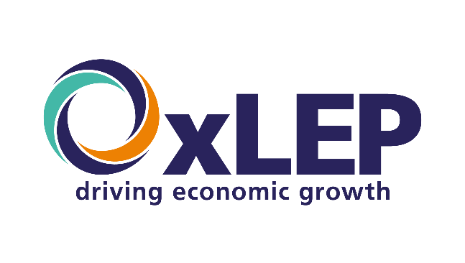

OXFORDSHIRE STRATEGIC ECONOMIC PLAN

REFRESH V4 – AUGUST 2024

Contents

Foreword 1

1. Introduction 3

2. Local strategic context 11

3. Understanding Oxfordshire’s economy 17

4. Approaching 2033: Key trends and drivers 34

5. SEP Ambition, Objectives and Themes 40

6. Theme 1 – Strengthening our communities locally 45

7. Theme 2 – Recognising our assets and using them well 53

8. Theme 3 – Supporting innovation across Oxfordshire 62

9. Theme 4 – Advancing Oxfordshire globally 69

10. Delivering the SEP 76

11. Measuring progress in delivering the SEP 82

# Foreword

We are pleased to present our 2024 Strategic Economic Plan (SEP) which provides a statement of economic priorities for Oxfordshire.

An earlier iteration of this plan was developed in partnership with a wide range of stakeholders, local authorities, the Future Oxfordshire Partnership, businesses, universities and colleges, community groups, social enterprise and individuals over a 12-month period between January and December 2023. A strong feature of the development process was proactive engagement with a wide range of workshops, briefings, and independent calls for evidence to ensure we created a plan that was representative of all aspects of Oxfordshire’s economy.

Subsequently a new body of work has emerged, much of it linked to the imperatives surrounding climate change adaptation in Oxfordshire. This has focused on the possibilities of the circular economy, the scope for community wealth building and the ambition to develop an ‘Oxfordshire Doughnut’ defined in pursuit of an ecologically safe and socially just space in which humanity can thrive. Nationally, there has also been a change in government. Although only a year old, the 2023 SEP has therefore been updated and refreshed in the light of these developments.

Our aim remains to champion good, sustainable growth that realises the following Ambition:

“*By 2033,* ***people and communities*** *across Oxfordshire will be benefitting from* ***new opportunities*** *which are* ***created sustainably*** *through* ***local enterprise and innovation****. These will enhance further their* ***wellbeing*** *in an* ***outstanding local environment****. They will also underpin, complement and support a wider* ***innovation ecosystem*** *which will continue to be of* ***global significance****, transforming for the better the lives of people across the world*“.

This statement of Ambition is aligned with the FOP Strategic Vision, its objectives and guiding principles. The intention is to ensure a ’whole system’ suite of connecting strategies focused on **making Oxfordshire a more inclusive, fair, vibrant and culturally rich place for our communities and businesses, whilst adapting to climate change and ensuring our environmental assets are respected and enhanced.**

The SEP highlights the vital importance of our foundational economy. Through this revision, it also draws out links to community wealth building, the circular economy and the ambitions surrounding the ‘Oxfordshire doughnut’. It recognises that all of these elements underpin our globally significant innovation ecosystem. Finding the balance across these will be critical to ensure that the county continues to prosper whilst protecting and enhancing our natural, cultural and heritage assets, and addressing the inequalities that many of our communities face.

Our role, going forward, is to continue to work closely with our partners to deliver on the Ambition of this plan and its four key Themes and Objectives. We will achieve this through ‘whole system’ working for the collective benefit of Oxfordshire’s communities and businesses alike.

Nigel Tipple, Chief Executive OxLEP, August 2024

Introduction

# Introduction

|  |
| --- |
| **Our new Strategic Economic Plan (SEP) updates and replaces Oxfordshire’s previous economic strategies**. Informed by a county-wide conversation, it provides a post-pandemic statement of economic priorities within the context of Oxfordshire’s wider commitment to sustainable development. It charts a positive economic future for the county, and it sets out our strategy to 2033. |

#### **An economic strategy developed at our own behest**

This document sets out Oxfordshire’s new Strategic Economic Plan (SEP), which looks ahead to 2033. It is the county’s fourth major statement of economic strategy over the last decade. It follows various iterations of the original Strategic Economic Plan (the latest from 2016), the Oxfordshire Local Industrial Strategy (2019) and Oxfordshire’s Economic Recovery Plan (2021).

This Strategy is different. It has not been prompted by central government. Nor is it a short-term response to an economic shock created by a health crisis.

Instead it has been initiated by Oxfordshire Local Enterprise Partnership (OxLEP) working closely with Oxfordshire County Council, the five district and city councils in Oxfordshire, and with Oxfordshire’s two universities (Oxford Brookes University and University of Oxford), all of which are members of the Future Oxfordshire Partnership (FOP).

Locally instigated, it has sought to take a step back, to consider the progress Oxfordshire has made and the opportunities that lie ahead, and to chart an appropriate route forward, given the changing mix of opportunities and imperatives.

#### **The progress that has been made**

On many measures, Oxfordshire has made good progress over recent years.

The Oxfordshire Inclusive Economy Partnership was identified as a priority action in the Economic Recovery Plan. It is now very well established, bringing together well over 100 organisations to create a more equitable place, and establishing an Oxfordshire Inclusive Economy Charter which now has many signatories.

When the SEP was published in 2016, *Oxford Science Enterprises* had just been formed; subsequently there have been more than 100 spin-outs from the University of Oxford which have secured £billions of early-stage investment. There have been some phenomenal success stories with regard to individual businesses. Oxford Nanopore Technologies was a small business at the time of the first SEP; it is now a recognised ‘unicorn’ with a market capitalisation of around £2bn. Oxford Bioescalator had just secured seed funding in 2016 (brokered by OxLEP via BEIS); now it is fully occupied and there is surplus demand for small business provision, particularly from small life science firms. Oxfordshire has also attracted significant interest from international investors and demand for (particularly) laboratory space has increased rapidly.

In addition, there has been significant progress in relation to wider developments. Oxford West End is being advanced through an ambitious vision for a well-connected, green, mixed-use neighbourhood that is a place of innovation; once completed it will provide 260,000 sq. ft. of employment space and 1,850 residential and student accommodation units[1]. Bicester has seen significant housing and population growth, and Bicester Vision has become a Community Interest Company. Development at North East Didcot has also progressed, while in West Oxfordshire, plans for Salt Cross are now well advanced.

However, some of the challenges identified a decade ago certainly remain. Transport issues – particularly those associated with the A34 – have made limited headway and the quest for active travel is ongoing. The affordability of housing continues to be an acute challenge county-wide; and Oxford has been ranked as the least affordable city nationally by Centre for Cities[2]. In addition, the challenges linked to environmental sustainability have grown since the earlier SEP was completed. There is, in particular, heightened awareness of the imperatives surrounding the Climate Emergency and the urgent need to make the transition to net zero carbon. There is also growing concern linked to the sustainability of resource use across Oxfordshire.

The overall assessment of recent years is therefore a mixed one – but perhaps inevitably so.

#### **Changing foundations for an economic strategy**

Against this backdrop, future growth in gross value added (GVA) remains important (because it will help people improve their standard of living).But we are not pursuing ‘growth at any cost’ and we are increasingly recognising that it must be done well, and without relying on ever-more inputs. **‘How’ we grow the economy is therefore critical** – as is the question of ‘**for whom’**. Growth must be achieved more **efficiently (particularly through productivity gains),** more **equitably** and more **sustainably**.

Two sets of comments follow, and both have been critical in framing this strategy.

First, there is increasing interest in broader interpretations of wellbeing. Economic growth, progression and social mobility need to go ‘hand-in-hand’ – such that the life chances of a child are not predetermined by those of his or her forebears. In similar vein, the importance of inclusivity is consistently recognised: wealth should be broadly held, such that there can be opportunity, dignity and wellbeing for everyone. And the importance of the foundational economy – with a focus on the activities and infrastructures that make civilised everyday life possible – is also increasingly understood.

Second, there is far greater awareness of the environmental costs and consequences of different forms of growth, and this has informed the SEP’s preparation. Particular insights have been drawn from the application of Doughnut Economics and its vision of an ecologically safe and socially just space in which humanity can thrive [**see Box 1-1]**. As we consider later, concepts such as the circular economy and community wealth building have gained considerable traction too, particularly as the wider costs of consumption are acknowledged.

**Box 1-1: Insights from elsewhere: Doughnut Economics in Cornwall**

A ‘Cornwall Doughnut’ has been developed at the heart of the **Cornwall Plan 2020-2050: Together we can**. This is the Cornwall and Isles of Scilly CIOS) Leadership Board’s shared vision. It re-interprets the principles of Doughnut Economics in the Cornish context:

* the environmental and social fields relate to dimensions that are locally measurable and where there is some degree of local control (e.g., fuel poverty and education; rather than ‘peace and justice’).
* the ‘safe space’ is defined as *“Sustainable ways of living for the wellbeing of future generations”*

Different elements of the Doughnut are measured on a Red-Amber-Green assessment which focuses on the direction of travel (shown below). An annual assessment of progress is included within the *Cornwall Plan Annual Review, 2023.*

*Figure A: The Cornwall Plan in 2023… RAG assessment*

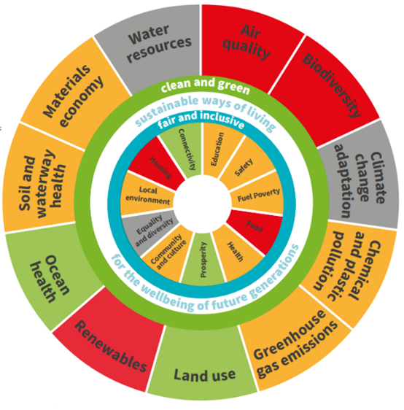

In addition, Cornwall Council has adopted a **Cornwall Doughnut Decision Wheel** as an appraisal tool[3].The guidance published by the Council says that it should be used “*during the development stage of a project or decision to help shape and inform the work requiring a decision*”. Estimated impacts are assessed on a number of dimensions – as shown below in relation to the Mid Cornwall Metro project.

*Figure B: Cornwall Doughnut Decision Wheel – applied to the Mid Cornwall Metro project*

#### **Putting the foundational economy at the forefront**

**Within the context set out above, we have paid particular attention to the foundational economy in framing this Strategic Economic Plan.**

This focuses on those parts of the economy that provide basic goods and services, upon which wellbeing largely depends. It includes ‘material’ (i.e. the structures and networks that connect households to daily essentials) elements and ‘providential’ (e.g. health, education) elements, and it accounts for well over half of the jobs in the county. Oxfordshire is a place where wages are typically high, housing is expensive, and labour and skills are in short supply. For all three reasons, the foundational economy has been under substantial pressure – with vacancies unfilled and service delivery very stretched. It therefore merits attention.

It is also important to recognise that these pressures have created consequential challenges in relation to those parts of the economy for which Oxfordshire is best known – whether the world class science at Harwell Campus; or the research and learning that occurs through University of Oxford; or the visitors to Blenheim Palace. Without an effective foundational economy, these other elements will struggle to function – let alone thrive.

**…and using our science, technology and innovation assets well…**

In advancing the SEP, we are committed to greater efficiency in resource use (as a core element of overall productivity) and to supporting the county’s response to the climate emergency. But we also recognise that within Oxfordshire, we have the science and innovation capacity and capability to develop solutions that should literally be game changers (and should help to decouple economic growth from resource consumption). Echoing key themes from *Mission Zero*[4]*,* this represents a substantial opportunity. Further, we have a growing population, and we need to ensure that Oxfordshire continues to be a place where people from diverse backgrounds can progress, flourish and enjoy a good quality of life; and where businesses can thrive.

**Oxfordshire needs to be a place where innovation and creativity can be unleashed and enterprise can thrive, benefitting people and places around the world, and delivering better environmental and social outcomes.**

#### **How the SEP has been developed**

The new SEP has been developed through a consultative process that has included:

* an Independent Economic Review – which involved an open call for evidence[5] and has focused on key issues for Oxfordshire:
  + enabling progression and achieving more inclusive economic growth
  + advancing net zero and sustainability in shaping future economic growth
  + securing the future of the foundational economy
  + accelerating innovation and diffusion – both within Oxfordshire and beyond.
* a participative process which has involved stakeholder engagement, particularly through a series of workshops which were held during spring 2023 in different parts of Oxfordshire.

The preparation of the SEP has been supported by a Working Group – with representation from Oxfordshire’s local authorities and universities – which has met monthly. It has also benefitted from a dialogue with the Future Oxfordshire Partnership and with the Board of Oxfordshire Local Enterprise Partnership.

The 2023 SEP was signed off by the Oxfordshire Local Enterprise Partnership Board in December 2023, before the transition to County Council responsibility. The 2024 SEP will be considered by the OxLEP Board and shared with all partners within the Future Oxfordshire Partnership. Oxfordshire County Council (through Cabinet) will have responsibility for its final approval, and for subsequent delivery support.

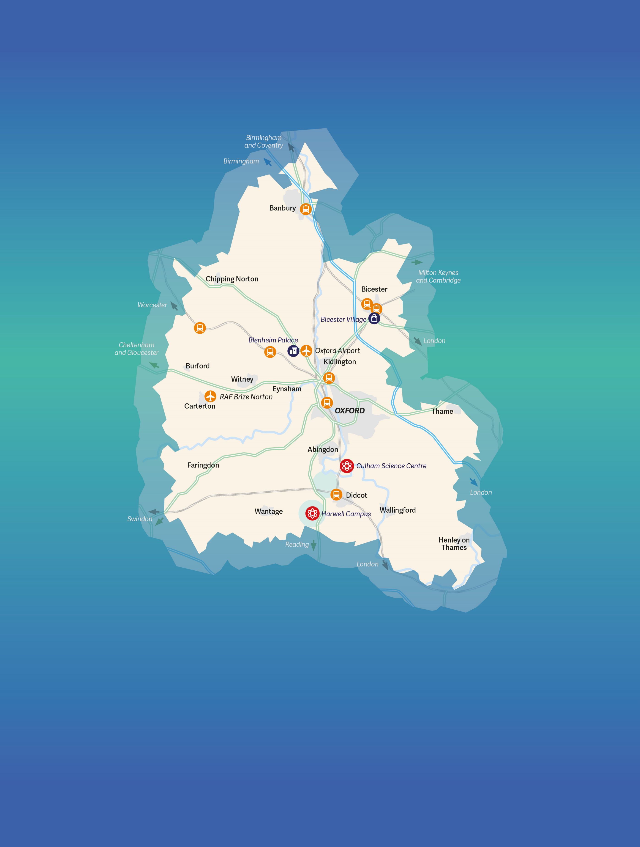

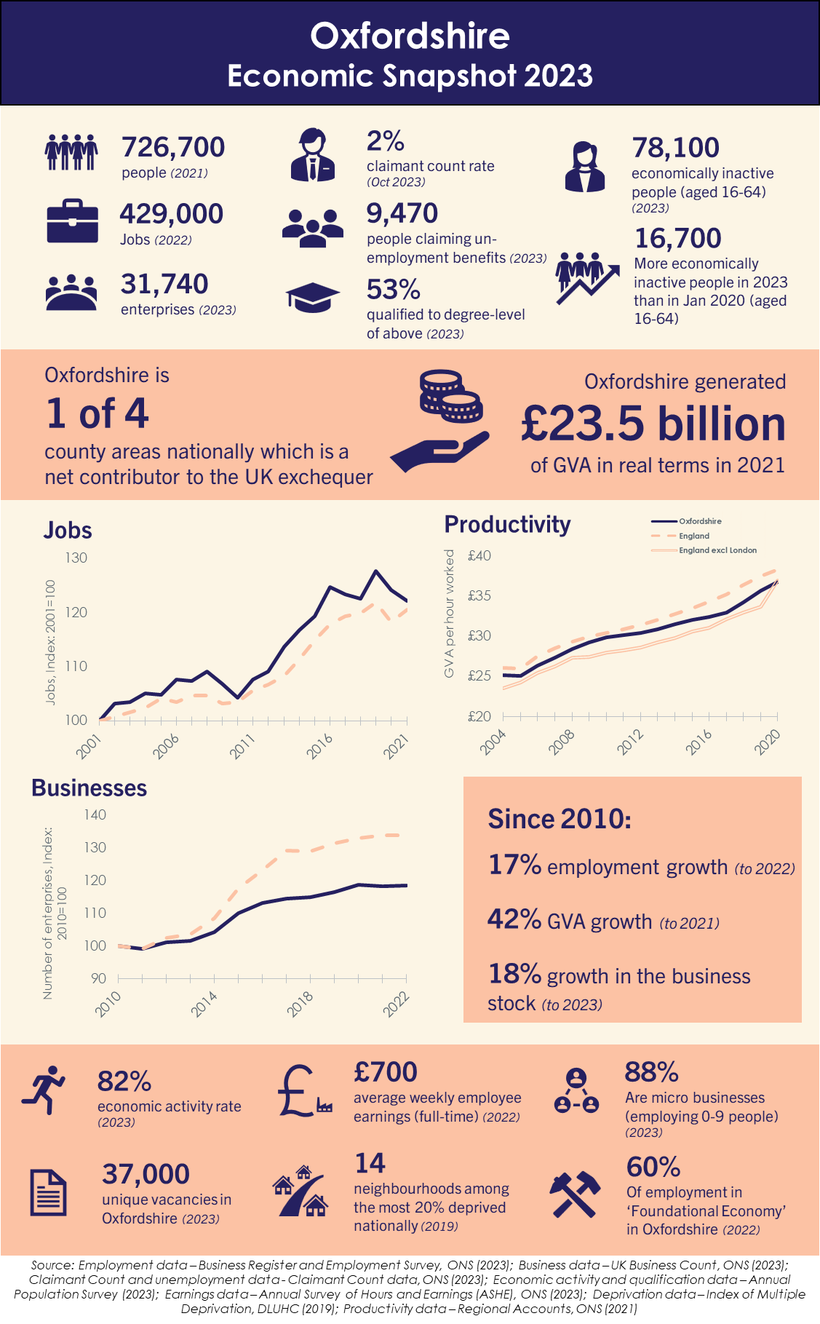

**Local strategic context**

# Local strategic context

|  |
| --- |
| The local strategic context is defined around the Strategic Vision which has been developed by the Future Oxfordshire Partnership – and its objectives and guiding principles. In practice the delivery of the FOP Vision will rely on a range of strategies, including the new SEP. These are nested within and articulated through ‘the Oxfordshire Story’, a new place narrative for Oxfordshire. In addition, Oxfordshire County Council is leading the way through workstreams linked to Doughnut Economics, the circular economy and community wealth building. |

#### **Oxfordshire’s Strategic Vision**

Within Oxfordshire, the **strategic context** for the new SEP is summarised through the **Strategic** **Vision** developed by the **Future Oxfordshire Partnership (FOP):**

Oxfordshire is a unique location: what we do here matters, not just for the benefit of our residents and communities, but also for the wellbeing of the UK and communities across the globe.

We are at the frontier in addressing and solving the most pressing challenges facing humanity. We want Oxfordshire to thrive so that the lives of current and future generations are improved.

To achieve this will require bold, collaborative, and inclusive thinking to deliver real and lasting change in ways that build resilience and enhance environmental, social, and economic wellbeing. We will draw on our world class economy, our spirit of discovery and Oxfordshire’s global reputation to power this change through the adoption of clean and sustainable technology.

At the core of this Vision are principles of sustainable development[6]. The Vision is supported by **nine objectives** (and eleven accompanying **guiding principles**). These are presented in a summarised form in Figure 2-1 (overleaf).

Some of the objectives are economic in focus. Some are predominantly social and/or focused on communities or places within Oxfordshire; wellbeing is implicit throughout. Several are concerned with the environment – whether the built environment, the natural environment or imperatives linked to resource use or carbon neutrality.

**The key point, however, is that all nine objectives are inter-dependent and all nine are critical in relation to the pursuit of the Vision set out by the Future Oxfordshire Partnership.**

Pursuing all nine will create some tensions and – at times – a need for choices and trade-offs. In relation to the implementation of the SEP, these are considered in detail in Chapter 9, (and a toolkit for appraisal purposes is set out). But the overall imperative is for partners to work together to achieve a thriving Oxfordshire, both now and in the future. Partners and stakeholders from across the county have signed up to this Vision and are committed to it.

The scope of the FOP’s Strategic Vision is substantial and well beyond that of the SEP – which is focused on Oxfordshire’s economy. However the SEP is determined to play its part in relation to all nine objectives.

#### **Delivering the Strategic Vision**

#### County-level strategies and plans

**In practice, the delivery of the FOP Vision will be advanced through a whole suite of thematic strategies which have been developed at a county scale and are inherently related to Oxfordshire as a place.**

Alongside the SEP, these include:

* **Pathways to Net Zero Carbon Oxfordshire (PAZCO)** – which outlines technological, societal and behavioural shifts needed to achieve net zero carbon and has in turn informed a Route Map and Action Plan (commissioned by FOP)[7].
* **Oxfordshire Energy Strategy** – which considers energy innovation and the need for a smart, modern, clean energy infrastructure.
* **Oxfordshire’s Local Nature Recovery Strategy (LNRS)** – which is under development but will identify priority species and habitats for Oxfordshire as well as the actions needed to support them.
* **Oxfordshire Food Strategy** – which is intended to improve Oxfordshire’s food system and make it more sustainable, affordable and resilient.
* **Oxfordshire’s Health and Wellbeing Strategy** – which sets out how different organisations and communities in Oxfordshire can work together to support the health and wellbeing of all residents.
* **Oxfordshire Local Skills Improvement Plan (LSIP)[8]** – which identifies skills needs in relation to seven priority sectors (some of which are within the foundational economy); it builds on the earlier **Local Skills Report and Plan** developed by OxLEP.
* **Oxfordshire Visitor Economy Vision and Destination Management Plan[9]** – which sets out a shared commitment to develop, manage and market Oxfordshire in a way which brings benefits to business, local communities, visitors and the environment.
* **Oxfordshire Infrastructure Strategy (OXIS)** – which considers a wide range of infrastructures (e.g. transport, utilities, waste, etc.) and identifies major infrastructure investments needed within Oxfordshire (e.g. A34 improvements, congestion measures linked to the A40, redevelopment of Oxford railway station).
* **Oxfordshire’s Local Transport and Connectivity Plan (LTP5)** – which sets out a vision to deliver a net-zero Oxfordshire transport and travel system involving less car-based travel and more sustainable/active travel.

#### In addition, there are ongoing initiatives led by Oxfordshire County Council which are also of formative importance. Many of these relate to the Council’s declaration of a climate emergency (in 2019) and its commitment to reach net zero as a council by 2030 and to enable Oxfordshire to be carbon neutral by 2050 at the latest. The County Council’s Climate Action Framework was developed in response and a series of related initiatives have followed. All of these have informed the 2024 refresh of the SEP. They include:

* the preparation of a **Community Wealth Building** strategy – which outlines how Oxfordshire County Council can use its economic activities (such as procuring goods or services, employing staff and owning land/assets) to generate reinvestment in the local economy (specifically in local people) which supports Oxfordshire to become ‘*fairer, healthier and greener*’ (consistent with its overall mission).
* the development of a **Circular Economy Strategy** – which seeks to eliminate waste and pollution, re-use products and materials (thereby reducing the overall use of resources) and regenerating natural systems. Within Oxfordshire, many different sectors are identified within (or with the potential to be within) the circular economy.
* a commitment to developing the ‘**Oxfordshire Doughnut**’, consistent with the principles of Doughnut Economics. Based on the work of Kate Raworth, this emphasises the need to create a space that is both ecologically safe and socially just, in which humanity can thrive. Key perspectives are structured through new thinking in economics – specifically ‘*seven ways to think like a 21st century economist’* in which the strong (20th Century) focus on growth in GDP is substantially reduced. Oxfordshire County Council is working with the Oxfordshire Doughnut Economics Collective (ODEC) – an informal network – to create an Oxfordshire Doughnut.

County-wide, the different strategies and plans are being delivered against the backdrop of the **Oxfordshire Story**, a new place narrative for Oxfordshire. This recognises what makes Oxfordshire distinctive. Its development was led by Oxfordshire County Council following extensive engagement and consultation.

**Box 2-1: *The Oxfordshire Story*: A place narrative for Oxfordshire**

A new place narrative – *the Oxfordshire Story* – has been developed to distil the complexity of places and people across Oxfordshire. It has been designed to inform a common set of ideas, images, and messages that leaders can communicate consistently and with high impact. The process of developing a place narrative – which has been highly participative – should expand the cohort of influencers who can celebrate and act as ambassadors for Oxfordshire.

Within *the Oxfordshire Story*, the county is variously described as:

* a place of national and global significance, and with the power to change lives.
* ‘pioneering green’ and a place with a precious natural environment, an ability and onus to champion and be an exemplar for the green economy alongside a sustainable approach to growth
* a ‘thinking hub’ fuelling economic growth and job creation across the UK.
* surprisingly diverse – urban and rural, and with many different communities
* a place to experience and enjoy history, culture and attractions
* a place that is changing the world for the better, every day.

#### City and district-level strategies and plans

Alongside the county-level statements, the Vision will be achieved through the suite of **city and district-level Local Plans** that exist across Oxfordshire. These are critical in relation to assumptions linked to future housing and jobs growth, and the provision that needs to be made for both. Local Plans are refreshed regularly, and they are underpinned by a substantial body of evidence and by democratic processes. The SEP will be delivered within the planning assumptions set out in these documents.

The Vision will also be delivered through other district-level strategies and plans – both the Economic Strategies that have been developed locally (e.g. Oxford’s Economic Strategy, 2022-32) and the strategies that have been prepared in response to other key themes (e.g. Climate Change Strategy for West Oxfordshire, 2021-25).

#### Key elements of the strategic framework and routes to delivery

**The SEP will be delivered in conjunction with these other strategies and plans, and emerging initiatives. In combination, these will deliver the Strategic Vision agreed by the FOP.**

Figure 2‑1: Key routes to delivering the Vision developed by the Future Oxfordshire Partnership (FOP), and its nine supporting objectives

|  |
| --- |
|  |
| Note that the diagram summarises various statements of objectives contained within the FOP Vision. |

**Understanding Oxfordshire’s economy**

# Understanding Oxfordshire’s economy

|  |
| --- |
| Whilst levels of affluence across Oxfordshire are relatively high overall, there are huge variations in life chances across the people who live in Oxfordshire and the communities of which they are a part. Many jobs are not well paid – and many people work within the foundational economy, delivering the goods and services that are key to everyday life. Oxfordshire’s key sectors are varied – ranging from creative industries through advanced manufacturing to the visitor economy and farming and food. Set alongside this, Oxfordshire has a world class innovation ecosystem, and its knowledge economy is of international renown. These different elements of Oxfordshire’s economy need to be recognised in full and the interdependencies between them need to be understood – and all within the context of a natural environment that is under pressure and an overarching need to adapt to climate change. |

#### **Introduction**

Oxfordshire’s economy has many different dimensions. There are currently about **430,000 jobs** county-wide, which has seen growth (particularly between 2010 and 2020) at a rate that exceeded the national average. These jobs vary in terms of the skills and qualifications on which they depend and the earnings they are able to command. There are therefore big differences among those who work in these jobs. Add to that those who are outside of the labour market – whether by choice or by circumstance – and the differences grow further. **Life chances vary substantially across Oxfordshire and understanding how these are shaped through the county’s economic make-up is critical in relation to the SEP**.

Oxfordshire’s overall output sums to **£23.5bn** in terms of gross value added (GVA). This is substantially generated by the activities of over **32,000 enterprises**, most of which are small. They are also scattered across Oxfordshire and they are focused on a wide range of sectors.

Through its businesses, Oxfordshire has strengths in: energy; creative industries; food and farming; visitor economy; health and life sciences; space; future mobility (connected and autonomous (self-driving) vehicles (CAV), automotive production and motorsport); robotics; artificial intelligence (AI); and quantum.

Within its business population are start-ups, spin-outs, high growth businesses, a handful of new ‘unicorns’ (with a market capitalisation in excess of £1bn – e.g. Oxford Nanopore Technologies) and major companies that have shaped Oxfordshire’s economy for decades (e.g. BMW, Unipart, Elsevier, Siemens).

**Oxfordshire’s economy is, genuinely, diverse.**

It also needs to be understood in its broader national context. Although in many respects Oxfordshire is a functional economic area (defined around commuting and migration patterns), there are key links beyond the county boundaries – whether north into the Midlands or south towards Thames Valley and London. These links have a substantial bearing on the county's wider economic roles, character and prospects.

#### **People and communities in Oxfordshire…**

Overall, employee earnings in Oxfordshire are relatively high. But across the county, there are substantial disparities in relation to income and wealth.

Data from ONS point to average household incomes of £48,500 in North Central Oxford compared to £26,300 in Blackbird Leys. In this context, the Centre for Cities ranks the City of Oxford as the second most unequal city in the UK in terms of income, housing, affordability and life expectancy. Similar patterns are apparent elsewhere in the county; in Cherwell, average household income ranges from £25,400 in Banbury’s Ruscote Estate to £43,600 in Bicester South[10]. These differences are substantial.

County-wide, housing affordability continues to be a challenge for many. The housing affordability ratio (the ratio between average house prices and residence-based incomes) was 11.1 in 2021; this had increased by 3.2 since 2003[11]. There are currently (July 2023) 9,540 people across Oxfordshire claiming Universal Credit and required to look for work (47% higher now than in March 2020). Overall, it is estimated that around 8-10% of households in Oxfordshire experience food insecurity[12].

Figure 3‑3: Deprivation in Oxfordshire[13]   
*(green is least deprived, red most deprived)*

*Source: Local Transport and Connectivity Plan – Baseline Report. Oxfordshire County Council, July 2022*

According to the Indices of Multiple Deprivation (IMD), Oxfordshire is the 10th least deprived of the 151 upper tier local authority areas in England. However, the IMD points to the scale of inequalities within the county. One area in Oxford is within the 10% most deprived areas nationally; and a further 16 areas (in Banbury, Abingdon and Oxford) are among the 20% most deprived nationally (compared with 13 in 2015). This suggests significant localised deprivation in Oxfordshire’s urban areas.

Data from the IMD also provide some insight into the extent of deprivation in rural Oxfordshire. Overall,some 21% of the county’s population lives within areas that are ranked within the worst 10% of areas nationally on the ‘geographical barriers to services deprivation’ domain. This suggests real challenges for those without access to private transport and it also points to the ongoing importance of local service provision in rural areas.

Data gathered in the context of Oxfordshire’s Health and Wellbeing Strategy provide further insights. They suggest that there are 15,900 children and 8,200 older people living in poverty within Oxfordshire. They also point to inequalities in health outcomes (which can be linked to gender, age, socioeconomic status, and ethnicity) and to substantial differences in life expectancy across different parts of the county[14].

**In the context of a county that can genuinely claim some of the world’s foremost science and technology assets – and entrepreneurs and investors who have driven successful commercialisation processes and built unicorn businesses – this juxtaposition sits very uncomfortably**.

Growth within Oxfordshire needs to be inclusive. It needs to be “*distributed fairly across society and create opportunities for all*”[15]. This is a key goal for Oxfordshire. Within this context, the challenges surrounding the delivery of affordable housing are uppermost, as is the provision of key public services – which links to the pressures on the foundational economy (discussed below). There is, in addition, a need for higher levels of educational attainment within Oxfordshire’s most in-need communities; and pathways to better employment opportunities for people who face barriers in accessing employment.

The imperatives surrounding inclusive growth are increasingly recognised. One part of the county’s response is through the work of the Oxfordshire Inclusive Economy Partnership [**see Box 3-1**].

**Box 3-1: Oxfordshire Inclusive Economy Partnership**

The Oxfordshire Inclusive Economy Partnership (OIEP) is a county-wide group that brings together employers, business, education, community groups and local government – to share knowledge, expertise and resources, and create links between different areas of work.  Its aim is to work together to create a more equal region that creates opportunities and benefits for all people within the county.   OIEP’s focus is on tackling areas that really need attention, which will have impact and will really make a difference.

OIEP has set up four action focused working groups to deliver its vision:

* **Educational attainment** - focuses on early years, educational attainment of GCSE English and Maths and better links between business and education to provide volunteer classroom support and help shape career choices.
* **Inclusive Employment** - focuses on both employers and employees.  It looks at how organisations can create better pathways into work whilst understanding the barriers people face to accessing employment.
* **Social value and procurement** - spending money locally puts money back into the local economy and creates opportunities for local businesses. It is looking at how Oxfordshire can grow the amount of money that is spent within our county, for our county.  It is also looking at how the businesses that benefit from this are investing into local communities, through jobs, training or improving the environment.
* **Place shaping** - investing in places that need it most.  Communities need to be part of the work to ensure that money spent in Oxfordshire helps address some of our biggest challenges – health, environment, housing. We need to ensure that we can answer these questions: What are the benefits that can be created for local people?  How are the benefits of economic activity and growth shared locally?

There is an OIEP Delivery Plan 2023-24 which sets out actions for the next 12 months.  However, the ambition of the OIEP goes beyond the delivery plan and will require a long-term focus on the key areas identified. Therefore OIEP has developed an OIEP Strategy 2023-26 which sets out the long-term vision and how it will reach its goals and objectives.

#### **…and opportunities for progression**

Inclusive growth needs to be an ongoing commitment and priority. There is a need to ensure that all residents have the skills and connections to be able to take advantage of the opportunities that are available locally – recognising that these opportunities are themselves changing (as new investment comes into the county, and as jobs and roles are changed through, for example, automation). Yet Oxfordshire’s employers are experiencing a tight labour market with chronic and acute skills shortages across many sectors. The challenges have been exacerbated by a rise in economic inactivity since the pandemic[16]: Oxfordshire’s economic activity rate[17] has been high but it has declined by four percentage points (or around 17,000 people across the County) since 2019[18].

#### **Oxfordshire’s foundational economy**

Most people in Oxfordshire work in sectors that are ‘foundational’: in other words, their jobs are concerned with responding to locally generated demand (and need), and the services they deliver generally have to be based locally.

Across Oxfordshire, **some 228,000 people – 60% of all people in employment in 2021 – worked in the ‘foundational economy’.** This includes people working in public services such as health and social care (45,000 people) and primary and secondary education (31,000 people). But it also includes a wide range of retail and leisure activities; parts of the construction sector; and the transport and utilities infrastructure that underpins the county’s economy[19].

The **foundational economy** plays a critical role: **it ensures that Oxfordshire ‘works’, with viable services, a good quality of life and a happier, healthier population.** As demand rises over time for services that need to be provided locally with significant personal input (for example, in social care), the resilience of the foundational economy is becoming more and more important.

This is true generally across Oxfordshire. But it is also true in relation to those organisations and individuals within the innovation ecosystem. These are major consumers of foundational economy services – and without those services, the innovation ecosystem simply could not function.

Oxfordshire’s foundational economy is however facing some challenges. These include the cost of living (including housing costs), reinforcing the consequences of low pay and relatively low margins in some sectors (especially personal service-related activities). There are also major challenges in staff recruitment and retention. These were exacerbated by the pandemic and also through settlement challenges following the UK’s departure from the EU. Long term labour shortages are described as acute in the LSIP (and OxLEP’s earlier Local Skills Report and Plan), particularly in foundational economy sectors such as hospitality, health and social care and logistics. There are also challenges (and opportunities) linked to the adoption of new technologies and the transition to net zero carbon across the foundational economy.

However, within Oxfordshire, these issues are widely recognised. There is a strong platform on which to build a more resilient foundational economy. Businesses increasingly see the value of social and environmental sustainability as a route to recruiting and retaining staff and building more resilient local supply chains, as evidenced in the growth of the B Corp movement locally and the development of the Oxfordshire Social Enterprise Partnership [**see Box 3-2**]. Spearheaded by business, local government and the universities, work is underway to increase the share of local public procurement spent locally, where it can provide greater reliability in public service and greater ‘rootedness’ in the local economy.

**Box 3-2: Oxfordshire Social Enterprise Partnership**

Oxfordshire Social Enterprise Partnership (OSEP) CIC is a social enterprise set up to support social entrepreneurs, Social Enterprises, enterprising charities and purposeful business across Oxfordshire.

OSEP has supported place-based approaches to promoting a local economy within Oxfordshire that is more inclusive, reduces inequality and promotes community wealth through proactive social enterprise infrastructure development in Oxfordshire. With support from OxLEP, it has recently delivered eScalate, a three-year project (which ended in April 2023) to support over 500 businesses to grow, through grant funding, peer support, workshops and 1-2-1 mentoring.

Progress is also being made in harnessing the value of Oxfordshire’s large rural economy in developing a food strategy that will reduce food miles, increase opportunities for healthier living and create a closer connection between production and consumption [See Box 3-3]

**Box 3-3: Oxfordshire’s rural economy and its strategy for farming and food**

Oxfordshire is a relatively rural county, and the least densely populated in south east England. Rural Oxfordshire encompasses a wide variety of settings, including the Cotswolds, the Vale of White Horse, and numerous market towns and isolated hamlets. These rural communities have suffered in recent years with the decline of retail and other services from these villages, and the decline in public transport links. This combined with rising fuel and transport costs (which adversely impact rural communities) has led to challenges in accessing work, education and services.

Farming continues to play an important role in Oxfordshire’s rural economy. Oxfordshire’s Food Strategy (developed by Good Food Oxfordshire) sets out aspirations to ensure that ‘everyone in Oxfordshire can enjoy the healthy and sustainable food they need every day’. This includes developing more sustainable food supply chains locally, ensuring that healthy and sustainable food is more affordable and accessible for everyone, encouraging local food businesses, and raising awareness of the importance of ‘Good Food’.

#### **Oxfordshire’s innovation ecosystem**

#### The evolving narrative

Oxfordshire’s assets in science, research translation, technology, and innovation achieved further expression during the pandemic. The county’s role both in developing an effective vaccine, and making it available quickly and at scale, achieved global recognition and impact.

**The last decade has seen considerable investor interest of different forms across Oxfordshire’s innovation ecosystem[20]; this preceded the pandemic but was accelerated by it**.

Public sector investment into the science and innovation infrastructure has continued apace – including, for example, through the Rosalind Franklin Institute, Nucleic Acid Therapy Accelerator, the National Quantum Computing Centre and additional investment into the Diamond Light Source synchrotron[21] on Harwell Campus; and through an 8,000 sqm R&D facility at Culham (supported by UKAEA).

Oxfordshire has also attracted substantial institutional investment. Oxford Science Enterprises (OSE) was set up in 2015 and it has subsequently increased investment in university spinouts *“from an average of £125m per year (2011-15) to £1.4bn in 2021*”.[22] Some of these have subsequently grown at the Bioescalator, and then at locations including Oxford Science Park, Begbroke Science Park and Milton Park. Oxfordshire in general – and Oxford in particular – has also attracted significant interest from overseas investors in office and laboratory space; GIC (Singapore) for example acquired a 40% stake in Oxford Science Park in 2021[23].

On a different front, Oxfordshire has attracted inward investment: in March 2023, Moderna announced its intention to establish a substantial Innovation and Technology Centre at Harwell Campus and more recently again, BMW announced plans to invest £600m in the MINI plant at Cowley in Oxford, focused on the manufacturing of electric cars[24].

There have been some challenges too – and some Oxfordshire stakeholders considered that the long period of non-affiliation with Horizon Europe[25] has limited international collaboration on major research and innovation programmes[26].

Nevertheless, **taken in the round, the last decade might be understood as a virtuous circle of investment of different forms**. The consequence has been a rapid growth in the stock of high-tech businesses[27] and associated employment[28].

One cause has been a ‘big bang’ of spinouts from University of Oxford, much of it propelled by OSE, as illustrated in Figure 3-1 below; and some of these businesses have grown very quickly.

Figure 3‑1: University of Oxford spinouts

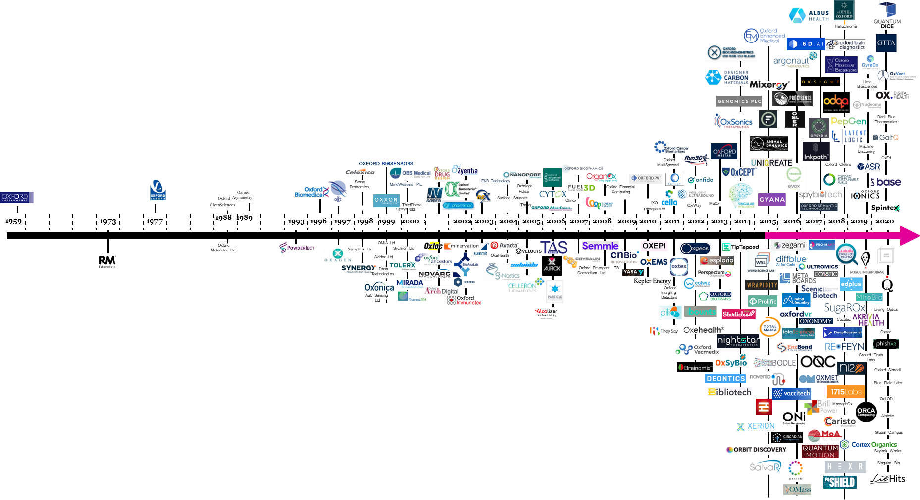

Source: Oxford Science Enterprises

#### A second has surrounded the wider economic impacts of major science facilities which have been animated more actively than hitherto. Harwell Campus, for example, has developed and delivered cluster strategies relating to energy, space, quantum computing, and health. As well as housing major scientific facilities, it is therefore supporting commercialisation and business growth at scale.

#### A third relates to the scale of international investment, as described above[29]. A fourth relates to the maturing of the wider ecosystem – whether through angel investment networks (noting for example that Oxford Angel Network merged with OION in January 2020 to create a unified angel network for Oxfordshire and beyond[30]) or the strong network of innovation centres county-wide.

#### The pressures of success…

The pace of investment has created some pressures. Rental levels for city centre office space and for accommodation on the major science parks across Oxfordshire doubled between 2016 and 2023[31]. There is a significant shortfall in the availability of laboratory space[32], particularly within Oxford (where demand is highest), while available office space is often of a poor quality.

There are major schemes within the development pipeline – and on one estimate, up to 1.9 million sq ft of office and laboratory space is due to be delivered between 2023 and 2025[33]. Examples of major schemes include Oxford North (almost one million sq ft); 135,000 sq ft of space for commercial/ University research at Begbroke Science Park; 625,000 sq ft of R&D facilities at Oxford Science Park; and an 80,000 sq ft venture at Milton Park. Longer term, there are plans for a science and technology park at Salt Cross in West Oxfordshire. The provision of commercial space should then increase – albeit with concerns surrounding its affordability.

In parallel, there are substantial pressures in relation to labour and skills supply. Evidence within Oxfordshire’s Local Skills Report and Plan (which preceded the Local Skills Improvement Plan) indicated that employers are reporting shortages of high-level technical skills, particularly in (what it describes as) the ‘innovation sector’. In this context, labour shortages have been amplified by settlement challenges following the UK’s departure from the EU.

#### …and the limits to wider diffusion

For Oxfordshire, however, a key question surrounds the extent to which investment in science and technology – and in the growth of knowledge-based businesses – is effecting economic transformation, both within Oxfordshire and beyond. Here the evidence is complicated.

Cluster strategies linked, for example, to Harwell Campus ought to be helping. Similarly the emergence of innovation districts ought to be consistent with broader processes of diffusion; the growth of Oxford West End should, for example, be significant in this context.

With the rise – and persistence – of home-based working in some sectors[34] since the start of the pandemic, stakeholders within Oxfordshire are seeing what they describe as ‘*diffusion by stealth*’ – as the spatial reach of labour markets grow and the opportunity to participate in Oxfordshire’s innovation economy extends across a broader geography. The consequences are, as yet, unknown: larger labour markets *might* ease recruitment and retention challenges, and working from home *might* ease congestion (at least on some days), but what are the consequences in terms of the processes of innovation, and in terms of carbon consumption? In terms of the latter, the balance between reduced emissions from commuting alongside the need to heat homes as workplaces during the winter months is important.

#### In sum: the global importance of the local

Oxfordshire’s innovation ecosystem has evolved – and is evolving – quickly, and in some respects, it is unrecognisable from a decade ago. Yet as Box 3-4 demonstrates, global competition is intense, and benchmarks are shifting too.

**Looking ahead, the future effectiveness of the innovation ecosystem will depend in large part on the character of Oxfordshire as a place – particularly in terms of affordability (of both housing and workspace), congestion, labour and skills supply, and the area’s quality of life (in all senses).**

Figure 3‑2: Businesses in Oxfordshire showing ‘Growth Signals’

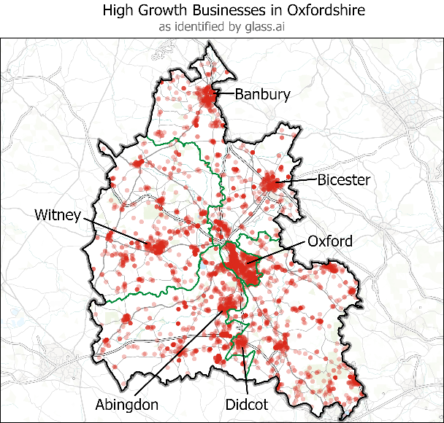

Source: Produced by SQW 2023 based on data provided by glass.ai. Licence 100030994

*Data: Esri, Ordnance Survey © Crown copyright and database right 2023  
Note: ‘Growth Signals’ have been identified through a web-crawl of Oxfordshire businesses, with a business tagged when its company website refers to one of: new offices, funding, collaborations, product launches and hiring. Some 6,129 out of 18,240 Oxfordshire-based businesses with a web presence were identified as having a ‘growth signal’.*

#### **Box 3-4: Global perspectives on investment into Oxfordshire**

#### Oxfordshire’s horizons in relation to science and technology are, rightly, global. But this means that the bar is set very high. Recent comparator data suggest that Oxfordshire’s international footprint is compelling relative to European benchmarks but still well behind those from North America. There are many reasons for this (not least spatial scales), but in aspiring to be a top three world class innovation ecosystem (the ambition set out in Oxfordshire’s LIS), there is no scope for complacency. As the data below demonstrate, across key knowledge intensive sectors, North American comparators continue to attract more early-stage investment than Oxfordshire.

Capital invested* over 2010-2023 in selected sectors**, Oxfordshire vs international comparators

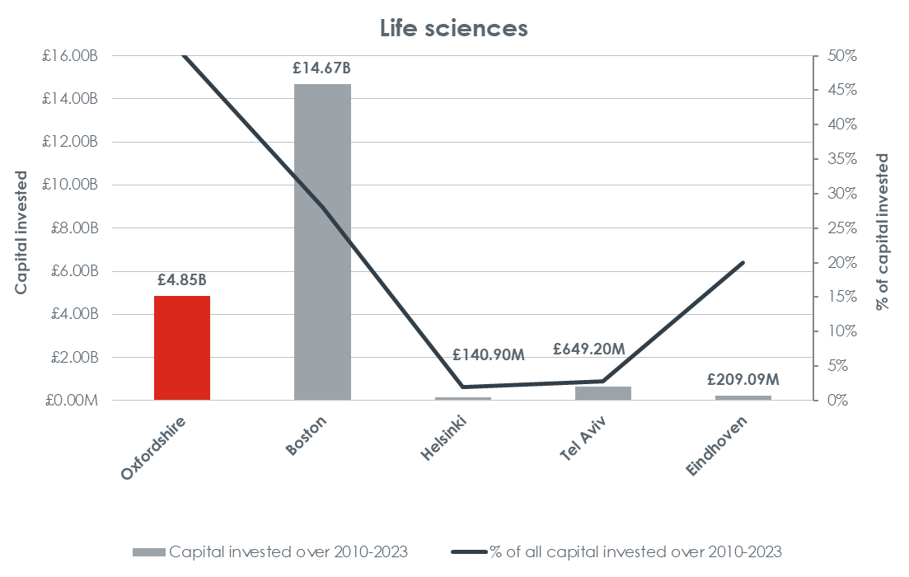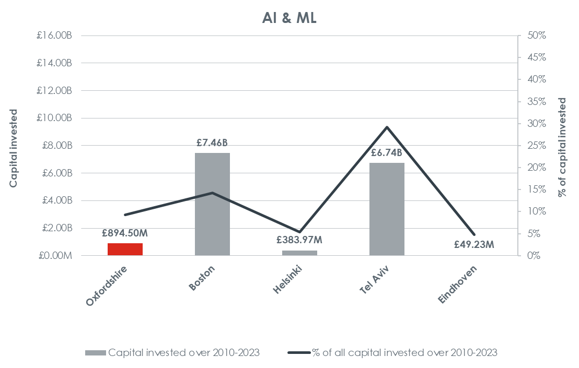

Source: SQW analysis of PitchBook Data, Inc. Data as at March 2023. Note that data have not been reviewed by PitchBook analysts  
* Capital invested in: Pre/Accelerator/Incubator, Angel, Seed, Early Stage VC, Later Stage VC, Other VC Stages (including grants), Private Equity Growth/Expansion, PIPE. Excluding failed/cancelled deals.  
**Note that values refer to investment tagged with the above sector keywords – as many deals are tagged with more than one keyword, the sectors (and therefore investment amounts) are not mutually exclusive.

#### **Net zero carbon, resource use and wider sustainability issues**

Cutting across all the observations set out above is a set of overarching imperatives linked to the climate emergency; related legal commitments to achieve net zero carbon; and wider sustainability issues, including in relation to Oxfordshire’s natural environment.

#### The journey to net zero carbon

In policy terms, Oxfordshire has made wide-ranging commitments in terms of the journey to net zero carbon. County-wide, the publication of *Pathways to Net Zero Carbon Oxfordshire* has been influential, as has the work of Future Oxfordshire Partnership (including through the commissioning and subsequent publication (July 2023) of the *Oxfordshire Net Zero Carbon Route Map and Action Plan*). At a local level, every council in Oxfordshire has committed to exacting targets [**see Box 3-5**].

**Box 3-5: Local commitments to net zero**

* **Oxfordshire County Council** declared a climate emergency in 2019. It developed a Climate Action Framework in response, with short-, medium- and long-term actions.[35] It has committed to being carbon neutral by 2030 across its estate and operations and to enabling a net zero carbon Oxfordshire through policies and partnership.
* The Zero Carbon Oxford Partnership has a target for Oxford City to achieve zero carbon emissions across the city by 2040.[36] **Oxford City Council** has committed to reducing carbon emissions and becoming a Zero Carbon Council by 2030.[37]
* **South Oxfordshire District Council** declared a climate emergency in April 2019, and in April 2021 declared an ecological emergency. As a result, it has set out targets to be carbon neutral within its own operations by 2025, and to be a carbon neutral district by 2030.[38]
* **Vale of White Horse District Council** declared a climate emergency in February 2019. It committed to be carbon neutral within its own operations by 2030, with an aim for a 75% reduction in carbon emissions in operations by 2025. Vale of White Horse District Council has also committed to be a carbon neutral district by 2045, with a 75% reduction in carbon emissions in the district by 2030.[39]
* **Cherwell District Council** has declared a climate emergency and will ensure its operations and activities are net zero by 2030. It has also committed to achieve a net zero carbon district.
* **West Oxfordshire District Council** has declared a climate and ecological emergency and made a pledge to become a [carbon-neutral council](https://www.westoxon.gov.uk/environment/climate-action/our-route-to-carbon-neutral/) by 2030.[40] It has committed West Oxfordshire to being a net zero district by 2050.[41]

Emissions of carbon dioxide are difficult to measure and, in some respects, to influence at a local level. They reflect national transport infrastructures; an inherited stock of dwellings; and long-established sectoral structures. But what is important is that *progress* is being made towards net zero carbon. There is also good evidence to show that – in particular places – locally tailored solutions can be more effective than those designed nationally[42].

In the context of the SEP, the business dimension is a central concern. The evidence suggests that Oxfordshire’s businesses have started to adopt net zero commitments [**see Box 3-6**]. However progress is patchy, and the available evidence suggests that public sector organisations and those in the energy/environment sector are leading the way. Encouraging more businesses (both SMEs and larger organisations) to consider emissions – and supporting them in the steps that might be taken to reduce them – will be crucially important looking ahead. Potentially this will impact on many different business operations – from the nature and geography of supply chains (and here the scope for local sourcing is important), to the extent and form of business travel, to the way commercial premises are heated. These imperatives apply to every SME in Oxfordshire – whatever the sector and wherever its location.

**Box 3-6: Businesses in Oxfordshire and the journey to net zero**

The business transition to net zero has already begun within Oxfordshire. To identify current activity, web-crawling was undertaken by glass.ai on Oxfordshire-based businesses/organisations to identify what proportion of businesses mentioned net zero on their websites and/or had related ISO standards in environmental adoption on their websites. Just over 5% of the businesses identified through the web-crawling exercise had made clear their commitment to net zero through their company websites (either by referring to net-zero and/or having related ISO accreditations). Larger businesses and those in the energy/environmental sector and public sector were the most likely to show adoption of net-zero practices.

**% of Businesses (by Sector) showing Adoption of Net-Zero Practices**

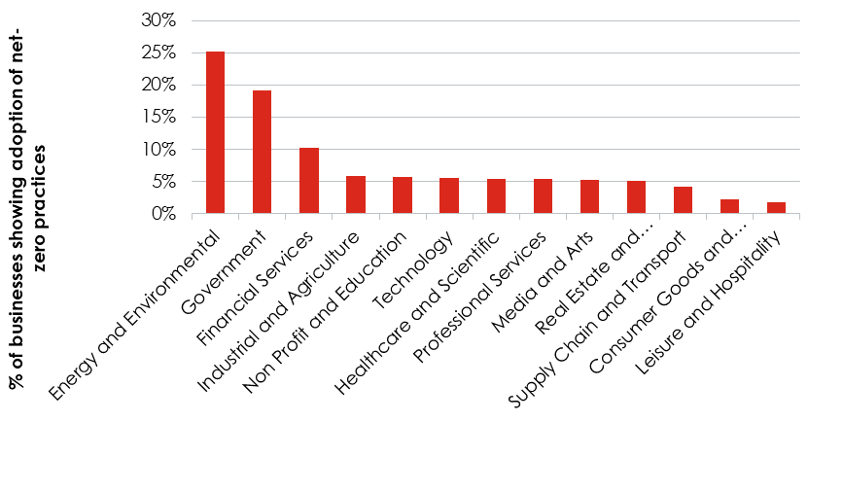

*Source: glass.ai data analysed by SQW  
Number of Business Records: 18,240*

The pathways to a zero carbon Oxfordshire (PAZCO) (2021) report provides detail on the current environmental contributions from the non-domestic sector. It notes significant variation in the design, fabric, and usage of buildings, as well as the business activity taking place.

Resources are identified to help organisations develop plans to achieve net zero. These include the SME Climate Hub (a repository of advice and resources) and Energy Solutions Oxfordshire (a new energy services company launched by the Low Carbon Hub and Oxford Brookes University to provide a one-stop shop for businesses looking to reduce their energy wastage).

#### Energy in Oxfordshire

In addition, there are key issues linked to energy in Oxfordshire. Currently, the energy supply network is under pressure. As set out in the Energy Strategy, there is a need for increased electricity grid capacity to support planned housing, industrial and commercial growth, and to reflect changing energy requirements. In the future, it will also be important to innovate so as to decouple growth from increasing energy consumption.

At the same time, the energy sector could potentially play a critical role in the medium/long term as a growing sector: already Oxfordshire has thriving clusters in energy and energy storage solutions [**see Box 3-7**]. It is a major national focus for innovation and investment currently – and it is a key part of Oxfordshire’s wider innovation ecosystem with critical nodes on Harwell Campus, Culham Campus, on Milton Park and within Oxford. Equally, there are a range of ventures progressing at more local levels, some of them community led.

**Box 3-7: Energy innovation in Oxfordshire**

*Fusion Technologies*

Key to Oxfordshire’s energy innovation landscape are the fusion technologies being developed at Harwell Campus and on the UKAEA’s Campus at Culham.[43]

While fusion is likely to play a large role in the future of clean energy, commercially viable products are unlikely to be readily available until after 2050 – so it is a long-term commitment.

However, there are economic opportunities for Oxfordshire linked to the technology developed as part of fusion research (for example, the magnets used for fusion are also used in healthcare; and there are some crossovers between the space industry and developing AI control systems).

Some Oxfordshire companies have attracted substantial investment in this context. One example is Tokamak Energy. It is pursuing fusion through the combined development of spherical tokamaks with high temperature superconducting magnets. Currently based on Milton Park, Tokamak now employs 200 people, and it is on track to deliver grid-ready power by the 2030s. The ST80-HTS spherical tokamak will be built at UKAEA’s Culham Campus, and a new facility is due to open in 2026.

Separately, in early 2023, UKAEA and First Light Fusion (currently in Kidlington) signed an agreement for the design and construction of a new purpose-built facility to house First Light’s Machine 4 at UKAEA’s Culham Campus. This strengthens further the suggestion that Culham is a leading location for public-private partnerships in fusion energy development.

However, while R&D remains firmly in Oxfordshire, the site of the first fusion energy plant is set to be in Nottinghamshire.[44]

*Energy Systems Accelerator pilot*

At a smaller scale, the Energy Systems Accelerator pilot – better known as Mini TESA – is a multi-disciplinary hub, championing technical and services innovation in the energy systems transition. The hub is based at Osney Mead in Oxford and began operating in Spring 2022. The hub accommodates two University research groups, the Low Carbon Hub (a social enterprise), and a team from Scottish and Southern Energy Networks (the local distributor)[45].

*Community Energy Projects*

It is also important to note that community energy is flourishing in Oxfordshire. The Low Carbon Hub has been central to securing funding and facilitating new community energy projects. The Ray Valley Solar project may be the largest community owned solar ground mount in the UK. Community approaches to renewable energy generation have the advantage of being able to access and raise different types of financial investment (such as community share offers), while building community support for large infrastructure projects.

#### Ecosystem services and natural capital

In parallel, there is growing recognition of the role of natural capital and ecosystem services in adapting to climate change and more generally. The importance of natural capital and ecosystem services is recognised in national policy (e.g. Biodiversity Net Gain is becoming mandatory), and key policy statements are in the process of being developed locally. In 2023, Oxfordshire County Council started work on the preparation of a Local Nature Recovery Strategy, working with Natural England and the District and City councils. This will provide a statement of biodiversity priorities and identify which areas of Oxfordshire should be prioritised for different kinds of nature recovery actions.

More generally, a resilient, thriving natural environment is important not only for a functioning economy, but for a happy, healthy society. Within this context, Oxfordshire Local Nature Partnership (OLNP) is working to enhance nature across Oxfordshire. Recognising that many businesses are committed to this agenda, it is exploring the scope for innovative financing mechanisms linked to addressing both ecological and climate emergencies[46].

There are many examples of local projects to enhance ecosystem services. One local example of an environmental charity working in the context is summarised in Box 3-8 below, drawing on material submitted through the Call for Evidence.

**Box 3-8: Earth Trust**

Earth Trust is an Oxfordshire based environmental charity with 40 years of experience in inspiring people to address climate, biodiversity and wellbeing with the power of natural green spaces.

Its own projects are generating new evidence, data and research partnerships to demonstrate the value of nature-based solutions in achieving net zero and addressing the climate, ecosystems and health crises. Examples include:

* Farming in a changing context - working with the environment to enhance a biodiversity partnership that assists in minimising the farm’s carbon emissions and maximising its carbon sequestration, whilst producing quality food.
* River of Life II wetlands creation – delivering the largest wetland creation project on the Thames, demonstrating flood plain as well as protected species and habitat nature-based solutions for climate resilience.
* Pioneers of Biodiversity Net Gain - providing an early exemplar of how biodiversity loss at one location can lead to enhancement of a rare habitat nearby.

#### **Conclusions**

Oxfordshire’s economy is complicated: it is highly innovative and has seen major investment and business growth (including much-prized unicorns), and yet there continue to be major challenges and some threats.

It has seen substantial investment in key assets and the organisations/businesses that use them are achieving impacts which are global – economically, environmentally and in relation to healthcare and wellbeing. **Looking ahead, those global impacts will not be achieved well – if at all – unless Oxfordshire as a place also thrives**.

A thriving Oxfordshire has many different facets. The effectiveness of the foundational economy will be critical, yet it is under enormous pressure currently. And those same pressures are the corollary of a place that is permeated by socio-economic inequalities which are increasingly and consistently recognised to be morally unacceptable across a diverse population as well as economically inefficient. A thriving Oxfordshire also needs an effective and resilient infrastructure, and this in turn needs investment.

All of this plays out in a place that includes an historic medieval city which is surrounded by Green Belt and is home to some of the best and most impactful science and learning worldwide; a series of historic market towns that are a primary focus for planned housing and employment growth; some major campus/business park locations which are known around the world and distributed across the Oxfordshire countryside (creating challenges in terms of accessibility); and an extensive rural area which has its own socio-economic character. Much of rural Oxfordshire is within the Cotswolds, Chilterns and North Wessex Downs National Landscapes (Areas of Outstanding Natural Beauty) and/or one of seven Special Areas of Conservation (SACs). Oxfordshire is also home to one World Heritage Site, Blenheim Palace (located south of Woodstock in West Oxfordshire).

Against this backdrop, the role of natural capital, and the ecosystems services linked to it, is being recognised as a key part of Oxfordshire’s infrastructure. ‘Blue’ and ‘green’ infrastructures are critical in terms of wellbeing and how places function. However, the pressures on Oxfordshire’s natural capital are clearly in evidence.

Oxfordshire’s other infrastructures – particularly transport, but also energy, utilities, digital, waste (and sewage) – are all under pressure and in need of investment. The transport system is congested, and the supply of energy is under pressure – partly because Oxfordshire is home to ‘big science’ and other research facilities which are significant energy users[47] and partly because of the pace of growth more generally. Digital connectivity has improved in recent years and is now reasonably good compared to national benchmarks[48]. Funding has recently been secured to enable Oxfordshire to become part of a new 5G Innovation Region[49]. Increasingly, Oxfordshire’s smart infrastructure will also have a critical role to play.

Within the context of infrastructure pressures, there are concerns about the nature of future economic growth. The SEP has been developed within the planning assumptions set out in Local Plans and hence the quantum of development is not for the SEP to determine. However the *quality* and *process* of economic growth – socially and environmentally – is a central concern.

Overall, Oxfordshire’s ‘efficiency’ as an economy is mid-ranking, compared to elsewhere in the UK [**see Box 3-9**]. This leaves little room for complacency and instead demands an effective and incisive SEP, supported by targeted investment to increase productivity and efficiency. This must navigate the interdependencies described above – and do so in a way that contributes to the Future Oxfordshire Partnership’s Strategic Vision for Sustainable Development.

**Box 3-9: Productivity in Oxfordshire**

Oxfordshire’s foundational economy is intertwined with its science and technology-based activities and with other parts of its ‘exogenous’ economy (e.g. creative, industries, visitor economy, automotive manufacturing, etc.), and there is a strong sense of symbiosis. All of these different elements are important in relation to the county’s overall economic performance and in this context, measures of productivity constitute a key indicator.

Nationally, the UK’s productivity gap (i.e. the shortfall compared to other countries) and productivity puzzle (i.e. the failure of productivity growth rates to return to pre-credit crunch levels) continue to be major concerns. They comprise a central theme within *Build Back Better: Our Plan for Growth* which was published in 2021. This continues to provide the most comprehensive statement of UK economic policy. It provides a framework for various ‘daughter’ documents – including the *UK Innovation Strategy (2021)*; the *Levelling-Up White Paper (2022);* and the *Ten Point Plan for a Green Industrial Revolution (2020).*

Productivity is important. It relates to the efficiency of growth and is concerned with how well the economy turns inputs of labour, capital and raw materials into outputs. It therefore has both environmental and social dimensions, as well as narrowly economic ones. It is determined by many factors, some more easily influenced than others. But it matters because it links to standards of living, and the scope to improve them. It should therefore benefit local communities.

Oxfordshire’s performance on the main productivity metrics is mid-ranking (when compared to other local economies in the UK). This is explained by its sectoral structure; its business demography (and the high incidence of SMEs); and by its geography and settlement structure, recognising that much of Oxfordshire is rural.

The data suggest that – if anything – Oxfordshire’s underperformance may be increasing. Given the supply side constraints under which Oxfordshire’s businesses operate – both in the foundational economy and across other sectors and activities – this observation is important. Through the delivery of the SEP, steps need to be taken to enhance productivity, recognising that greater efficiency could also help to support the journey to net zero carbon and the pursuit of other objectives set out within the FOP Vision.

**Productivity in Oxfordshire – county, districts and comparators**

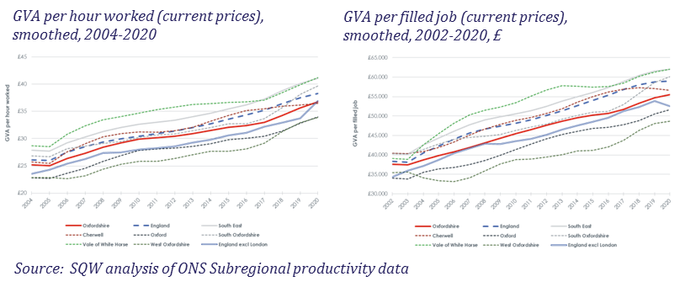

**Approaching 2033: Key trends and drivers**

# Approaching 2033: Key trends and drivers

|  |
| --- |
| Looking ahead over the next decade, there are wider trends and drivers – social, technological, environmental, economic, and political – which will affect businesses and communities across all parts of Oxfordshire. Read alongside the description of Oxfordshire’s economy (in the previous chapter), these help to define a series of opportunities and threats to which the SEP must respond. |

From both the Independent Economic Review and feedback from the stakeholder workshops held whilst developing the SEP, a series of critical trends and drivers were identified. Some of these are generic – insofar as they will affect most local areas in the UK. However, **how they will affect Oxfordshire – and the businesses, people, communities and places within it – is unique, determined in large part by the county’s characteristics** (as described in Chapter 3).

#### **Social Drivers**

Social driversrelate fundamentally to people and communities. In Chapter 3, the diversity of lived experience across Oxfordshire was described – from those who are clearly struggling to make ends meet and are in food poverty (even if they are in work), to others who are, on any measure, affluent.

In the near term, the **cost-of-living crisis,** compounded by **rising interest rates**, is a major concern, particularly for those who were anyway struggling to cover the costs of housing (whether servicing a mortgage or paying rent). These issues are affecting many in Oxfordshire, including those working in the foundational economy; those working in the visitor economy (which includes tourism, culture, arts) and the creative industries; and many of those in lower paid jobs within the innovation ecosystem (e.g. post-doctoral students, lab technicians, etc.).

Looking ahead, the challenges of **labour market progression** are real – particularly given housing affordability pressures. In the future, **job changes** will be frequent, and ‘progression’ may well assume different meanings, but transferable skills are likely to be very important.

Commentators have written about the rise of ‘guppies’ – young professionals in their 20s and 30s who have ‘given up on property’ (in contrast to their parents in the 1980s and 1990s). A **new relationship to home ownership** is associated with all sorts of lifestyle changes, typified by those within Gen Z (i.e. born in the 1990s and early 2000s). Described as ‘digital natives’, this cohort includes the younger part of the current workforce – and it is characterised, perhaps, by **greater demands for purpose and accountability** **from employment** (particularly in relation to environmental concerns), and greater recognition of – and sensitivity to – **diversity**. There is also likely to be a **greater interest in wellbeing**, especially given pressures linked to **social media**. These observations are generalisations, but as the younger members of the workforce move to more senior positions, their motivations are likely to move with them, shaping in time the future of economic life across Oxfordshire.

Another major social driver relates to the process of **population ageing** which is being seen across much of the UK (outside of major cities). Deficiencies in **pension provision** – particularly among those who are not homeowners – and a **rising state pension age** will compel people to work for longer; jobs may well need to change to accommodate workers well into their 70s.

In addition, as the age profile shifts, the **dependency ratio** will grow – and so will demand for key local services, particularly health and social care; in the future this will have a major bearing on the foundational economy, both in terms of the scale of demand for it and the associated funding issues linked to it.

#### **Technological drivers**

Over the ten years of this SEP, there will be further technological shifts linked to **artificial intelligence (AI) and the use of data.** The consequences are likely to be wide-ranging and profound. Many activities will be **automated,** and jobs will therefore be redefined. At the same time, **data security** is likely to become more and more problematic and better/stronger solutions will need to be found. The threat linked to **cyber security** will constitute a major risk. While it will represent an opportunity for businesses which are specialised in the field (including some major firms in Oxfordshire), it will mean that every business and household in the county will need to be far more digitally literate. AI will play a role in relation to cyber security.

AI is likely to **transform service delivery**. It will affect healthcare and education, and ‘routine’ functions like logistics. It will also affect connectivity and mobility (including, potentially through autonomous vehicles, etc.). In many different respects, AI could become all-pervasive – and indeed, it is already shaping many different spheres (whether or not this is recognised fully).

Over the timescale of the SEP, there is a strong possibility that **quantum technologies** will see significant growth. This represents an important opportunity for Oxfordshire.

Another major technological driver is likely to be in the sphere of **regenerative and personalised medicine.** Again, there are real potential prizes here for some of Oxfordshire’s life sciences businesses, but the implications for healthcare are likely to be substantial.

Alongside these ‘known technological drivers’, there is scope for unexpected technological disruption, given the speed with which new tech is being created and adopted. Profound technological disruption is possible, even within a single decade.

#### **Environmental drivers**

Over the next decade, imperatives around **transitions to net zero**, including with regard to energy infrastructure, will be crucially important. Whilst national targets are set for the 2050, significant progress will need to be made during the lifetime of this SEP consistent with the targets set out in the *Oxfordshire Net Zero Route Map and Action Plan* commissioned by FOP.

This will (or should) have wide ranging implications – including, for example, in respect of energy production and consumption; air travel; use of private cars; the construction and insulation of buildings; use of plastics; dependence on data centres; and so on. It presents both opportunities and challenges for the local area. The transition to net zero is creating whole new sectors (linked for example to emission free flights). Businesses / organisations across Oxfordshire are well placed to respond.

For Oxfordshire’s businesses, an important question will be whether international competitors gain/lose a temporary competitive advantage through differential national approaches to – and rates of – transition to net zero carbon.

Looking ahead, there will be **more extreme weather events** – and businesses will need to both plan and adapt as part of their more general approach to mitigating, managing and adapting to the effects of **climate change**. Measures to enable business continuity are likely to be important, and the threat of extreme events could help precipitate a transition to re-shoring (especially given the disruption caused to global supply chains through the pandemic).

Within this context the importance of **natural capital** will increase further. Potential **biodiversity loss** and the consequences for local (environmental) **ecosystem services** (e.g. with regard to flood mitigation) will also need to be recognised as a risk and a driver[50]. Important implications will follow, particularly with regard to the use of agricultural land and the management of water (and other) resources.

#### **Economic drivers**

Over the next decade, economic drivers are equally uncertain. They will be shaped in part by geopolitics, but also by shifting patterns of international trade.

Over the very recent past, the growth of the **Chinese** economy appears to have faltered while the performance of **Emerging Market** economies has been inconsistent. As **North America** and **Europe** adjust to ‘higher for longer’ interest rates, the possibility of slow (or even no) growth appears much more likely.

**Longer term trends however suggest that the geopolitical and economic landscape is shifting to the east**. Asia – particularly China and India – are emerging as significant centres of power and influence. Over time, the dominance of the United States and Europe may diminish in relative terms.

The **cost of capital** has increased with higher interest rates, and the inference – in general – ought to be reduced investor confidence. It could be that Oxfordshire bucks the national picture, but the wider backdrop must be one of financial uncertainty.

Over the next ten years, the expectation also should be a series of new **trade deals**. These may open new opportunities for businesses in Oxfordshire, whilst closing others.

The ‘**competition for talent’** looks set to continue over the next decade, recognising that new and different skills will be required. **This ‘competition’ will need to be seen as an international one, particularly amongst younger workers**. As Oxfordshire aspires to retain and grow its world class knowledge economy, the implications of competition for talent are likely to be very important (including, for example, through the need to provide schooling for the children of highly qualified international migrant workers).

#### **Political drivers**

In a domestic context, the UK saw a change of government in July 2024, and a new Labour administration.

Early policy priorities for the new government include:

* accelerating the pace of economic growth
* addressing the housing crisis and introducing planning reforms
* advancing both deeper and wider devolution, as a route to addressing spatial disparities across the UK
* supporting clusters and place/area-based economic assets – and committing to a new Industrial Strategy
* achieving green growth and making headway in relation to net zero carbon targets
* redefining the UK’s role and profile internationally.

However it is important also to consider political drivers that are international in character. These include: geopolitical instability (notably war in Ukraine and conflict in the Middle East); the possibility of emerging bilateral alliances, particularly given levels of debt in some less developed nations; the structures put in place to deal with misinformation, including in relation to cybercrime; and the range and effectiveness of global responses to climate change mitigation and adaptation.

#### **Conclusion**

The next ten years are laced with uncertainty. In one sense, this is obvious, but the degree of risk is unprecedented. Unpredictable and extreme events – sometimes described as ‘black swans’ – are growing in frequency and severity. In the aftermath of a pandemic, the fragilities of a highly interdependent world are there to see.

For Oxfordshire’s SEP, the risks of the next decade need to be recognised and understood. The aim, essentially, is to build the county’s economic resilience and to do so in a manner that aligns with the FOP’s Strategic Vision for long term sustainable development.

**SEP Ambition, Objectives and Themes**

# SEP Ambition, Objectives and Themes

|  |
| --- |
| Oxfordshire’s Strategic Economic Plan is guided by a high level statement of **Ambition** (which is consistent with FOP’s Strategic Vision). The Ambition will be supported by four cross-cutting **Themes** and four delivery **Objectives**. |

## Ambition

Consistent with the Future Oxfordshire Partnership’s Strategic Vision for long term sustainable development, the **Ambition** which sits at the heart of our Strategic Economic Plan may be summarised as follows:

*By 2033,* ***people and communities*** *across Oxfordshire will be benefitting from* ***new opportunities*** *which are* ***created sustainably*** *through* ***local enterprise and innovation****. These will enhance further their* ***wellbeing*** *in an* ***outstanding local environment****. They will also underpin, complement and support a wider* ***innovation ecosystem*** *which will continue to be of* ***global significance****, transforming for the better the lives of people across the world.*

Our emphasis therefore is on *Oxfordshire’s people and communities* – both those who live and/or work here now, and those that are likely to do so by 2033.

We will continue to emphasise the importance of *wellbeing* in an *outstanding local environment*. This is wellbeing for everyone across a diverse population and in all senses – recognising that being equipped for, and contributing to, a changing economic life is a critical element in terms of agency, dignity and self-esteem. We also want to emphasise our cultural assets in this context, and the importance of creative places to support social and economic health and wellbeing. This relates to all places across Oxfordshire – Oxford itself, the historic market towns, and the villages within our extensive and beautiful countryside.

We recognise that *new opportunities will be created, and new jobs will be formed*. Some of these will involve roles and occupations that do not yet exist and for which we will need to be prepared. But in readying ourselves, the *process of enterprise and innovation* will be encouraged actively, across all parts of our economy: small and rural businesses as well as much larger and more established firms, and across all sectors.

We also intend to ensure that *Oxfordshire continues to thrive in relation to its global roles* – particularly those concerned with its *innovation ecosystem* – and that it secures the infrastructure investment which is needed to allow it to do so. We are in the business of conducting outstanding research and commercialising the findings effectively, such that wellbeing can be improved around the world.

## Objectives

In order to achieve our Ambition, we have identified **four key Objectives**.These are generally stated, but they are critical as delivery priorities. The SEP will seek to advance all four, working in concert with other strategic processes across and beyond Oxfordshire:

* **Objective 1:** Ensure that Oxfordshire’s **places are sustainable and inclusive**, and that **local communities flourish.**

We will support the lead role of our local authorities in realising the full potential of our places. Specifically we will work with the District and City councils and local communities, to ensure that all of Oxfordshire’s places are sustainable and vibrant, and that they provide the range and scale of both market and affordable housing and workspace (of different forms) that have been identified through Local Plans.

* **Objective 2:** Enable Oxfordshire’s **businesses to thrive** and encourage **pervasive innovation.**

We will support businesses in Oxfordshire – from across the foundational economy, from within the innovation ecosystem, and from other key sectors and clusters (e.g. visitor economy and creative industries). Within this context, we especially recognise the need for innovation – by which we mean adaptation and change with regard to what is produced and how it is produced.

* **Objective 3: Widen access** to current opportunities and **equip people and places as jobs change** over the next decade.

We will work to ensure that the breadth of current and emerging opportunities across Oxfordshire are widely available. In this context, neither the age of individuals nor any other protected characteristic (disability, gender reassignment, race, religion, etc.) nor the places in which they live should be seen as barriers to access.

* **Objective 4: Secure resilient infrastructure** for planned growth, consistent with Oxfordshire’s commitment to net zero carbon by 2050 and wider imperatives linked to the sustainability of resource use.

We will work with our partners to make the case for infrastructure investment of many forms – notably transport, digital infrastructure and energy infrastructure. We will emphasise the importance of this investment in realising future growth potential – and in enabling Oxfordshire (and particularly its key businesses and major knowledge-based institutions) to continue to fulfil its wider roles, globally and nationally. In so doing, we will support the delivery of the Oxfordshire Infrastructure Strategy. We will also work alongside other key groups, notably the Fast Growth Cities (FGC) group[51] and the Sub-Regional Partnership (discussed later) in making the case for appropriate investment[52].

## Themes

The four delivery Objectives will be shaped through **four cross-cutting Themes**:

1. **Theme 1: Strengthening our communities locally**
2. **Theme 2: Recognising our assets and using them well**
3. **Theme 3: Supporting innovation across Oxfordshire**
4. **Theme : Advancing Oxfordshire globally**

These **Themes cut across the four Objectives**. Their purpose is to help to avoid siloed thinking, ensuring that synergies are captured, and progress is made. They are explained in detail in subsequent chapters.

## SEP Vision, Objectives and Themes

Through the delivery of our **Objectives** and **Themes**, we will achieve the **Ambition** of the SEP.

We will also make a critical contribution to **achieving the Future Oxfordshire Partnership’s wider Strategic Vision.**

Figure 5-1: The SEP’s Objectives and Themes – and their contribution to the FOP Strategic Vision

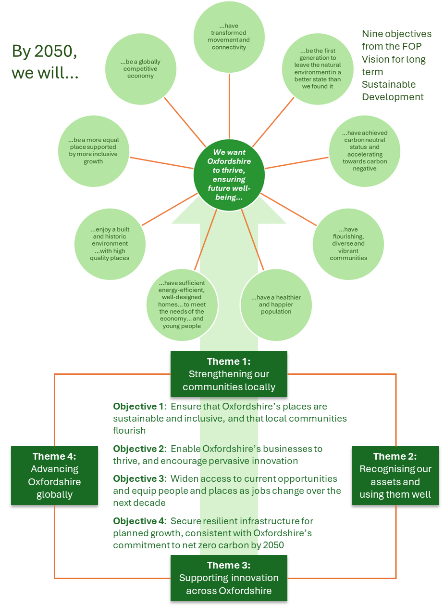

**Theme 1 – Strengthening our communities locally**

# Theme 1 – Strengthening our communities locally

# 

|  |
| --- |
| The success of Oxfordshire over the next decade will depend on the extent to which we can improve the quality of life for current and future residents in all parts of the county, rural and urban, whilst also adapting to climate change and wider imperatives linked to resource use. Our first Theme therefore focuses on how we can make sure that the benefits of growth are captured locally and sustainably, ensuring that our diverse communities are able to thrive. It recognises the importance of inclusivity, accessibility, and connectivity at a local level, and the role of Oxfordshire County Council and the district and city councils across Oxfordshire in curating sustainable places. |

#### **Curating places across a diverse county**

Oxfordshire is a diverse county. The city of Oxford itself accounts for around 22% of the county’s total population, with a network of towns (such as Abingdon, Banbury, Bicester, Didcot, Henley and Witney) making a substantial contribution to the county’s economy, and its built environment and cultural assets. Beyond the main settlements, Oxfordshire is the least densely populated county in the South East, with its smaller towns, villages and rural communities contributing to a large land-based and visitor economy, as well as accommodating some of Oxfordshire’s key innovation assets.

Oxfordshire also welcomes newer communities, whether within the ‘footprint’ of older settlements or in newer developments. Over time, these will develop distinctive identities and will contribute to Oxfordshire’s diversity. Businesses will also play an important role in healthy place shaping, ensuring that a range of local employment opportunities is available. The Strategic Economic Plan must help to ensure that these new communities – and the businesses within them – can thrive.

Much of the county’s local distinctiveness is linked with the quality of its natural and built environment, much of which is protected. If Oxfordshire’s economy is to grow sustainably, it is vital that these key assets are preserved and enhanced – recognising that they contribute to the county’s success and quality of life.

**Box 6-1: Oxfordshire’s outstanding environment**

Oxfordshire benefits from the infrastructure of one of the world’s greatest city-regions, with easy access to London and good strategic connectivity to the rest of the UK.

But within this complex and highly networked regional context, it contains areas of deep rurality and great environmental significance. These include three National Landscapes (Areas of Outstanding Natural Beauty) (the Cotswolds, the Chilterns and the North Wessex Downs), as well as four National Nature Reserves and 109 Sites of Special Scientific Interest.

This environmental quality sets much of the context within which sustainable economic growth will take place.

#### **Building social capital**

Oxfordshire benefits from a strong network of community organisations. There are over 3,400 charities registered in the county, a relatively dense concentration of organisations which ranges from major international bodies such as Oxfam to smaller local groups. There is also an extensive network of locally-based business groups, complementing the structures that exist at county-wide level. These are important in building ‘social capital’ – the links between individuals and communities that help to ‘get things done’ locally, build business relationships and supply chains (including within the foundational economy), share ideas and enable communities to become more resilient and inclusive. Developing a stronger and more ‘locally embedded’ economy means building these networks and enabling more to happen organically at community level. The good news is that Oxfordshire is *relatively* well-placed to do this, through the community assets that it has in place.

**Box 6-2: Zero Carbon Oxford Partnership**

Zero Carbon Oxford is a partnership that brings together universities, hospitals, councils, large businesses, and communities that has committed to achieving net zero carbon emissions for the city of Oxford by 2040. It has set out a detailed roadmap to reducing its emissions, focusing on a pipeline of actions to build momentum and galvanise local communities to support better practices and new projects to help the transition to net zero. These actions are grouped around five key sectors: domestic, commercial, industrial, transport and institutional.

#### **Quality of life everywhere, and for everyone**

However, as explored in Chapter 3, not all communities are equally placed to enjoy Oxfordshire’s relative prosperity and future economic opportunities. While there are relatively few concentrations of deprivation in Oxfordshire, inequalities are high, and are compounded by high living costs. Alongside the Action Areas set out in Theme 3, which include a focus on developing individual opportunities for skills and progression in work, the Strategic Economic Plan also takes a community-based approach to building wealth and capacity locally. Particularly in this context, it recognises the critical role of Oxfordshire’s city and district councils. Oxfordshire County Council is also important. It is developing a wide-ranging approach to Community Wealth Building [see Box 6-3]. In addition, its Community Capacity Grants are helping to expand the work of community groups and enable people to live well and independently in their communities.

**Box 6-3: Oxfordshire County Council’s approaches to Community Wealth Building**

Community Wealth Building (CWB) is a set of approaches that seek to widen the access that local people have to the wealth held in Oxfordshire’s economy. Good community wealth builders are anchors in the local place, cognisant of the impact they have as an economic unit, as well as a service provider. Community wealth building facilitates access to financial wealth, or property that brings investment to local people. In addition, CWB also generates wealth for local people in the form of security, cultural capital, relationships, agency and power for example.

Oxfordshire County Council is seeking to use its own economic activities (such as procuring goods or services, employing staff and owning land/assets) to generate reinvestment in the local economy (specifically in local people) which supports Oxfordshire to become fairer, healthier and greener.

Oxfordshire County Council is also committed to advancing economic development that brings benefits for people and place in Oxfordshire – including through the delivery of the SEP

Across the county, **access to housing** is a key issue underpinning people’s quality of life. Median house prices are over 10.5 times resident earnings in Oxfordshire (compared with around eight times resident earnings in England as a whole). Within this context, the picture in the city of Oxford is especially challenging. Securing a supply of housing to meet identified need will also be crucial in underpinning Oxfordshire’s investment ‘offer’.

In parallel, it is essential that there is a **supply of affordable workspace**. The challenges are acute across Oxfordshire – there are commercial pressures and employment land is in danger of being lost, yet local employment sites and affordable workspace are critical if Oxfordshire as a whole – and the villages and towns within it (including Oxford) – are to continue to function effectively.

In addition, there is a need for **local infrastructures** which can enable sparsely populated areas to thrive. Villages in Oxfordshire need to be places where people can work if they are to function as anything other than dormitory settlements. The food and farming sectors, and the visitor economy, will both make an important contribution. In addition, working from home increasingly has a role to play – albeit well-performing digital infrastructures are vital. Oxfordshire County Council’s Digital Infrastructure Programme[53] is important in this context, and various local initiatives have also been developed. It is important that these continue to be encouraged [**see Box 6-4**].

**Box 6-4: Oxfordshire’s ‘Gigahubs’**

The ‘Gigahub’ project aims to install full fibre broadband infrastructure into a range of public service sites in Oxfordshire. Oxfordshire County Council has agreed to add investment to DCMS’ original funding, extending the scope to include a number community centres, additional schools, GP Practices and libraries.

Over 175 sites across Oxfordshire (including schools, libraries, leisure centres and community centres) will be connected with gigabit capable broadband. This improved connectivity is vital for ensuring that communities are connected to the internet (e.g. through public Wi-Fi connections, public computers and for local services) and provide the connectivity needed for enabling future innovation (e.g. drone corridors and connected autonomous vehicles).

#### 

#### **Adapting to climate change – and the circular economy**

#### Cutting across all of this, there is an on-going need to adapt to the consequences of climate change. For the food and farming sectors, the issues are immediate – but every part of the economy, and every place in Oxfordshire will need to respond. Wider imperatives and opportunities linked to the circular economy have a key role to play [**see Box 6-5**].

#### In many respects, this is a cross-cutting consideration. It also sits at the core of the FOP Vision – and therefore at the heart of the Strategic Economic Plan.

**Box 6-5: Oxfordshire County Council – and its commitment to the circular economy**

Currently, within Oxfordshire as elsewhere, we ‘take, make, use, and dispose’. We take resources from the ground, air, and water; we make them into products and structures; we use them and then we dispose of them.

In a circular economy we would reduce material and energy use in the first instance, keep materials in use for as long as possible, and cycle and reuse materials at their highest value.

Oxfordshire County Council is advancing its focus on the circular economy with reference to:

* its direct activities such as the waste generated by day-to-day operations
* the goods and services it procures such as major infrastructure projects and social care contracts
* Oxfordshire’s households, recognising that Oxfordshire County Council and the city and district councils are responsible for collecting, managing, and processing household waste
* the wider Oxfordshire economy, which Oxfordshire County Council does not control but can influence – for example through the SEP.

#### **Key Areas for Action**

To capture the goals of Theme 1, the Strategic Economic Plan seeks to **recognise and nurture the distinctive economic roles and contributions of all of Oxfordshire’s places**. While Oxfordshire is diverse, economic assets are quite widely distributed and a balanced approach to economic activity across the county ought to support Oxfordshire’s long-term sustainability.

In this context, key Areas for Action – most of which will continue to be led by local authority partners – include:

* **Championing social entrepreneurship across Oxfordshire.**

Increasingly, charities, social enterprises and purposeful businesses are building businesses that trade for environmental and social objectives, as well as to make a financial return – and a commitment to wider objectives is of growing importance in attracting and retaining staff. Oxfordshire is ‘leading the way’: building on the work of groups such as Aspire, SOFEA and OSEP CIC, social entrepreneurship will become an increasingly prominent feature of the business landscape and will help achieve more inclusive growth.

* **Building capacity in the voluntary and community sector**.

As set out above, Oxfordshire has a large charity sector and a dense network of local community groups. But the VCS also plays a critical role in the foundational economy and in the resilience of many public services – increasingly so in the context of pressure on public sector budgets. The aim is to enable growth while retaining and nurturing local roots.

* **Encouraging ‘community wealth building’.**

Linked with the growth of social entrepreneurship and the expansion of the voluntary and community sector, 'community wealth building’ is about exploring ways in which more of the returns from economic growth can be sustainably retained locally and put to community use. This often involves community ownership of assets, which may include local amenities, but could also include local energy generation schemes or goods and services in the ‘sharing’ economy. This is likely to be easier to achieve in those parts of the county that are more affluent and enjoy more ‘social capital’ in the first place: it will be important to advance these principles across all of Oxfordshire’s places and communities.

* **Building local supply chains**.

Substantial work has already been done via the Oxfordshire Inclusive Economy Partnership to create opportunities for local suppliers from some of Oxfordshire’s key public sector purchasers, including the universities. Linking this with efforts to build the density of local business networks should increase the ability of firms to respond. Shorter supply chains will also yield environmental benefits, with initiatives such as the Oxfordshire Food Strategy supporting health, environmental and economic outcomes.

* **Unlocking the ‘circular economy’.**

As set out in Box 6-4, through the lens of the circular economy, the aim is to reduce inputs and waste, by re-using goods as far as possible, and recycling the residual. This is a key driver of innovation, both in new ways of using and adapting materials and in developing new services that help to reduce overall consumption. There is also an important community dimension which can also help to reduce costs and create community-based business models.

* **Supporting businesses and communities in rural Oxfordshire.**

Much of Oxfordshire is rural and there is a need to support rural businesses and the communities that rely on them (for employment, for local economic vibrancy, and for service delivery). In this context, we need to ensure that provision is made for affordable workspace in rural areas, including through meanwhile uses. We also need to build on the learning from recent programmes (e.g. LEADER, Businesses in Rural Oxfordshire) and those that are emerging (e.g. Rural England Prosperity Fund).

* **Advancing the network of innovation hubs across different places in Oxfordshire**.

There is high demand for innovation space within the existing stock, and increased remote working creates new opportunities. Local authorities, universities and developers will work together to expand access to the innovation network, wherever firms are based in the county.

* **Supporting Oxfordshire’s food and farming sectors**

Building on the Oxfordshire Food Strategy, we need to support the food and farming sectors county-wide. This could deliver important benefits: increasing the proportion of food consumed and grown locally would reduce food miles and associated carbon.

We also need to support agricultural businesses to transition to a regenerative model and deliver carbon and biodiversity benefits. Oxfordshire is playing a growing role in this context through, for example, the work of FarmEd (based in Shipton under Wychwood, in West Oxfordshire)[54].

* **Planning for sustainable housing growth, in the context of coordinated plans for place-shaping.**

Planning for places is complex. The right quantum and distribution of housing will be determined through the planning process. The sensitive nature of much of Oxfordshire’s landscape, the need for significant change to achieve net zero and the need to deliver identified housing need mean that a coordinated approach to housing, infrastructure and the economy is vital through local plan-making. Although the local authorities ceased to work on the joint Oxfordshire Plan 2050 in 2022, an on-going dialogue across (and indeed beyond) Oxfordshire will also continue to be important.

In the shorter term, advancing [Community Employment Plans](https://oxlepskills.co.uk/employers/schemes-initiatives/community-employment-plans/) for new developments will also help to ensure that local communities benefit from new developments.

**Theme 1 – and links to other strategies within Oxfordshire**

| Strategy | Connections with Theme 1 |
| --- | --- |
| Oxfordshire Local Skills Improvement Plan (LSIP), 2023 | * People are at the core of the LSIP, with a key ambition being to provide inclusive, accessible education and training for all in Oxfordshire. This includes ensuring that education and training opportunities better reflect the needs of Oxfordshire’s workforce. |
| Oxfordshire Food Strategy, 2022 | * In ensuring that everyone in Oxfordshire can enjoy healthy and sustainable food they need every day, the Food Strategy identified a number of initiatives, including supporting Community Wealth Building approaches to preventing food poverty, building resilient communities and developing skills, jobs and enterprises that retain wealth locally. |
| Oxfordshire’s Health and Wellbeing Board Strategy, 2024-30 (forthcoming) | * This emerging strategy recognises the influence of financial wellbeing on people’s health, with deprivation a significant cause of ill health.  It supports the SEP’s ambition that the local economy should be inclusive, equitable and fair, and that everyone should be able to contribute through life-long learning and good quality and stable work. |

**Theme 2 – Recognising our assets   
and using them well**

# Theme 2 – Recognising our assets and using them well

|  |
| --- |
| **Theme 2** is concerned with **productivity in Oxfordshire**. It relates fundamentally to the effectiveness and efficiency of economic activity across the county. The imperative is to use resources and capital well – human capital, natural capital, investment capital. In so doing, the aim is to build economic resilience that can enable wellbeing for people and communities across Oxfordshire. |

**Introduction**

**Theme 2** is concerned with **productivity in Oxfordshire**. There is a strong link between productivity and standards of living. **Increased productivity must be achieved sustainably and in a way that improves overall wellbeing (linked, for example, to reduced inequality and greater economic inclusion)**; it therefore has many different dimensions. In focusing on productivity we are not advocating accelerated growth in overall output beyond that which is consistent with current planning assumptions; instead, **we are encouraging better, smarter and cleaner economic activity to benefit both current and future generations**.

**Productivity and the foundational economy**

Businesses and organisations operating within the foundational economy are under pressure in Oxfordshire, particularly in respect of labour supply and skills: many are struggling to recruit and retain the staff needed to deliver key local services (such as health and social care, public transport, retail and visitor economy more generally). In this context, measures to increase economic activity levels, and to support (re-)entry to the workforce are likely to be important, particularly in relation to older workers (some of whom left the labour market during the pandemic) and those who might face other barriers to employment.

Within this context, there are particular challenges facing SMEs. These vary substantially in character. They include sole traders, new businesses, long-established family-owned firms, and social enterprises, and many play a key role within the foundational economy. During the stakeholder workshops which underpinned the preparation of the SEP, two key elements were flagged consistently:

* **Continuing low levels of digital literacy and adoption among Oxfordshire’s SMEs:** Those working locally with SMEs noted the challenges of online application processes for support during the pandemic, in part because many SMEs appeared to lack basic financial software for managing their businesses. The imperatives surrounding digital literacy will grow over the next decade, and Oxfordshire’s SMEs need the tools and the confidence to respond, improving their own efficiency in the process.
* **Affordability and supply of workspace**: Oxfordshire is expensive and as sites are redeveloped, whether for housing or high-end commercial premises (particularly at the moment laboratory space), locally focused SMEs are often displaced. Some have been able to adapt by working from home and/or by moving to smaller premises, but this is not always possible, and the provision of appropriate affordable workspace is a county-wide challenge [**see Box 7-1**]. There are examples of local solutions – particularly as town centres adapt to the restructuring of retailing – and it will be important that these continue to be supported [**see Box 7-2**].

**Box 7-1: Provision for employment and affordable workspace**

Employment space within Oxfordshire, particularly around key business locations, is on an upward trajectory, with prime office rents currently at an average of £60 per sq ft[55] and rental values for 4-5 Star[56] office stock having risen by 25% between 2020 and 2023[57].

More generally, the supply of employment space has become increasingly constrained in recent years, with Oxfordshire’s businesses struggling to find affordable workspace to meet the needs and/or growth aspirations of their businesses.

The provision of affordable workspace is important in providing local businesses and organisations with security to stay in spaces and lowers risks to growth, therefore encouraging more investment in capital and people. It is also important in ensuring that Oxfordshire retains businesses which are of economic, social and community value, particularly those within the foundational economy, and voluntary and social enterprises.

There are examples in other employment space-constrained environments of policies to ensure that some level of workspace is available to meet the needs of local businesses, particularly those which are integral to the function and character of a place. The Greater London Authority and London Boroughs have put in place planning policy to ensure that there is a sufficient supply of affordable workspace across the Capital, with a focus on providing space for those businesses which add to the sense of place, community and environment of the City.

**Box 7-2: Meanwhile in Oxfordshire…[58]**

This is a county-wide initiative to reanimate underused space in our urban centres. The £1.9m project was developed by Oxford City Council. It is being run by social enterprise Makespace Oxford, with the funding secured by OxLEP from the central government’s Getting Building Fund.⁠

The project ‘Meanwhile in Oxfordshire…’ is seeing vacant retail units in local high streets transformed into independent shops, cultural venues, creative studios and co-working spaces.

Good progress is being made towards the aim providing affordable premises to accommodate more than 100 organisations, which will create or secure at least 300 jobs.

‘Meanwhile in Oxfordshire…’ is reducing the number of vacant units in the county’s high streets by enabling entrepreneurs to fill them with new and innovative enterprises and organisations. This is diversifying the offer in Oxfordshire’s town and city centres, giving people more reasons to visit and to keep on returning.

Makespace Oxford has formed a consortium with other local organisations to combine the expertise and knowledge needed to deliver results across the county. This partnership includes Wild Property, Transition by Design, Soha Housing, Fusion Arts, Aspire Oxfordshire and Independent Oxford, alongside national experts in this field, Meanwhile Space CIC.

In aggregate, the loss of less productive SMEs and the reallocation of assets linked to them might be seen as part of a natural economic evolution. But – again in aggregate – these businesses are central to Oxfordshire’s overall economic fabric, and they deliver important local services. Encouraging investment in both people and core business processes is therefore important.

**Productivity and automation**

Over the lifetime of the SEP, automation will be a major driver, including in relation to the foundational economy. Analysis by PwC suggests that internationally, around 50% of jobs linked to transport could be displaced by automation by the mid-2030s and about 20% of those linked to health[59]. Given labour market pressures within Oxfordshire, there may be some upsides – although the consequences are unpredictable. PwC also notes that 44% of those with low skills/qualifications are at risk from automation – suggesting that those consequences will be experienced unevenly. The implications are substantial, both for the way key services within the foundational economy are delivered and the job prospects of the people who work in them.

For Oxfordshire to become more productive – particularly in the context of technological change and automation – workforce skills will be very important. A strong link with local schools will be essential, recognising the critical role of schools in shaping much of Oxfordshire’s future workforce. At the same time, it will be important to recognise that learning must not stop when compulsory education ends. As noted in Oxfordshire’s Local Skills Improvement Plan (LSIP), the aspiration has to be to ‘*train people for careers not jobs’,*  with transferable skills (including, but not restricted to, digital skills).

**Productivity and progression**

A more productive economy is likely to require a more highly skilled and better-paid workforce. This implies progression within work, where low paid roles act as the ‘first step’ to better paid jobs in the longer term[60]. The risk, however, is that some low-paid workers remain ‘stuck’ in jobs that do not realise their full potential. This may reflect a lack of development opportunities to enable them to progress, or specific barriers (linked, for example, to a disability), or caring responsibilities and other life circumstances.

In a tight labour market, it is important to make best use of all our resources. This is also important in achieving inclusive growth. It reinforces the ambitions set out in the LSIP, and there should be opportunities for employer leadership.

**Productivity and home working**

The pandemic led to an immediate switch to working from home for many people. The ‘return to the office’ has been slow and patchy and there is evidence to suggest that the pandemic helped crystalise demand for a permanent shift to working from home and/or hybrid office-home working. How this will affect productivity in Oxfordshire is currently unknown and unknowable, but the extent of the change in working arrangements will have some level of impact – both directly (e.g. through the process of work) and indirectly (e.g. through potentially reduced congestion).

**Productivity and congestion**

In part because of its rurality, levels of car use and car ownership are high across Oxfordshire. Located at the core of the national transport network, the evidence points to growing road congestion over much of the last decade. In Oxfordshire, the M40 and A34 are both part of the Strategic Road Network, and both saw speeds decrease in the years before the pandemic. The decrease in road speeds was however greater on the county’s A roads (in line with the national average); and within this, the greatest deterioration was seen on the A4185 and the A4130. In parallel, the reliability of frequent bus services in Oxfordshire has decreased in recent years, in part because of congestion, whilst movements of freight were affected by – and contributors to – growing congestion[61].

Congestion within Oxford is part of the challenge. Oxford is effectively a ‘central hub’ in relation to public transport across the county. Projects such as the Cowley Branch Line could reduce the number of private vehicle journeys and increase access to jobs, education and training. It could therefore help to tackle inequality in the county and improve opportunities for local people[62]. A feasibility study has recently been completed for a rail link between Carterton, Witney, Eynsham and Oxford. Although in its very earliest stages, this scheme could also potentially contribute to improving access and reducing journey times[63].

There is much evidence to suggest that congestion affects productivity – because of the time absorbed through travel. It also affects environmental performance. In Oxfordshire, transport is responsible for a larger proportion of greenhouse gas emissions than the national average, producing 36.5% of all emissions in the county and within this, road travel is the major contributor[64]. The inference is that reduced congestion is important in terms of the county’s ambitions with respect to net zero, as well as its productivity performance.

**Productivity and net zero**

There are potentially synergies in terms of measures to increase productivity and those to achieve net zero carbon. A recent report identified, *inter alia*: a shared focus on the efficiency of resource use; the need for investment on both fronts (net zero will be a driver of investment that should also influence productivity growth); a shared dependence on processes of innovation; and a common link to new jobs and new skills[65]. The opportunity to increase productivity whilst effecting the transition to net zero is one that the SEP is seeking to harness.

**Productivity and resource use**

Productivity also has important links to wider patterns of resource use – water, land, energy, utilities, minerals, waste, etc. All of these are under pressure to varying degrees – partly as a result of the scale of population growth, and partly as a corollary of some of Oxfordshire’s distinctive assets and specialisms. Its ‘big science’ facilities at Harwell and Culham are, for example, major users of energy.

The imperative to achieve resource use efficiency is therefore clear. In this context, traditional ‘linear’ economic models (where resources are used, consumed and discarded) increasingly need to be replaced; instead, concepts linked to the circular economy will have a key role to play.

**Key Areas for Action**

In response to the issues identified above, a wide range of Areas for Action have been identified. These include:

* **Supporting Oxfordshire’s SMEs to navigate the transition to net zero and enhance productivity, particularly through the use of digital solutions.**

As discussed above, many SMEs are late adopters on the digital front, and much could be gained by accelerating progress. Progress towards net zero carbon ought also to be possible if a series of operational improvements is encouraged. Across these different elements, business support and access to finance will be key to improving outcomes for SMEs. Oxfordshire’s Growth Hub will have an important role to play, delivering support as well sign posting and connecting to local and national partners such as the Business and Intellectual Property Centre (BIPC)[66].

* **Learning about the relationships between productivity, innovation and remote working, and disseminating best practice.**

The post pandemic ‘new normal’ is still being defined and the consequences in terms of long-term productivity are still a matter of conjecture. Through Oxfordshire’s research community, steps should be taken to gather and benchmark relevant evidence.

* **Working with partners to improve social mobility for young people and ensure that they have greater access to career pathways within Oxfordshire**.

Recognising that many of the jobs/occupations that will define young people’s working lives do not yet exist, there is a need to support future skills initiatives, identified through the LSIP and through other routes.

* **Providing better coordinated support for people getting (back) into the labour market.**

Levels of economic activity declined during the pandemic and there is a need/opportunity to encourage more people to return to the labour market. For older workers, this may be especially important as the deficit in relation to pensions provision becomes clearer.

More generally, there is a need to work with businesses, the voluntary sector, Department for Work and Pensions, and health and care providers to offer support to people who experience the greatest barriers to obtaining fairly paid, secure, local employment. This includes people with long term health conditions, ex-offenders and adults with learning difficulties. Anchor institutions have a particularly important role to play in offering employment opportunities to people experiencing disadvantage.

* **Working with schools, and then with employers and providers, to equip people for a working life in which job roles will change frequently (through automation, etc.).**

There is much uncertainty in relation to future job roles, etc., but it is widely expected that the next decade will see significant changes. Working through the Local Skills Improvement Plan (LSIP) process and more generally, there is a need for an ongoing dialogue, including with Oxfordshire’s schools, to ensure that people are equipped for careers rather than jobs, and therefore able to adapt as the demands of employers change. Services like those supported through the Careers and Enterprise Company will be very important in this context.

* **Raising awareness of the Oxfordshire Inclusive Economy Partnership’s (OIEP) Charter and encouraging more employers in Oxfordshire to commit to it, and to wider ventures linked (for example) to the BCorp movement**.

The challenges and responsibilities in relation to inclusive growth have become clearer and within Oxfordshire, there is a high level of commitment to it. More employers ought to be encouraged to respond. This could include, for example, taking on apprentices; paying a fair local wage; and increasing local procurement, as well as signing the OIEP Charter itself.

* **Working with partners to facilitate sustainable travel to major employment locations.**

Some of Oxfordshire’s major employment sites have challenging locations vis-à-vis public transport and they are relatively inaccessible. Developing and delivering sustainable solutions is an ongoing priority.

* **Working with partners to use existing employment land well, recognising different sectoral needs and the imperative for affordable workspace whilst acknowledging links to housing.**

Employment land supply is limited and there are significant demands for it. In delivering the SEP, it will be essential to recognise the requirements of key growth sectors whilst also making appropriate space available for lower value uses, recognising that these are a key element of the foundational economy on which Oxfordshire relies. Key strategic employment sites will need to be used effectively (and they will need infrastructure investment to make this possible).

In this context, there are clear links to housing provision. Homes must be built with links to employment in mind – whether this is working from home (which should affect the design of dwellings) or proximity to major employment locations. It will also be important to make provision for co-working space (particularly for those who live in smaller dwellings and need/want to work near to their homes).

* **Levering more of the economic potential from Oxfordshire’s military sites.**

Military sites in Oxfordshire (e.g. RAF Brize Norton) are an important part of the local economy and there is scope to build on this through, for example, the development of local supply chains. In addition, military leavers have important and valuable skills. Some establish their own businesses within foundational economy sectors, whilst others can support knowledge economy activity (e.g. through advanced manufacturing). Oxfordshire LEP has supported military leavers previously, and similar interventions will be important looking ahead. In using our assets well, the importance of Oxfordshire’s military assets – both people and sites – should be recognised fully.

* **Recognising the importance of Oxfordshire’s rural economy and links to both food production and land use.**

The rurality of Oxfordshire is one of its principal – and most valued – characteristics. Its countryside is important in terms of the amenity it provides, but also in terms of the land resources associated with it. These need to be used effectively and well.

**Theme 2 – and links to other strategies within Oxfordshire**

| Strategy | Connections with Theme 2 |
| --- | --- |
| Oxfordshire Local Skills Improvement Plan (LSIP), 2023 | * They key priorities for change identified within the LSIP complement the Areas for Action identified in the SEP, with the ambition to ensure that the County has the right mix of people, skills and opportunities. The LSIP looks to:   + Provide inclusive, accessible education and training that meets the needs of learners, helps employers to develop their existing workforce and help individuals move up the career ladder.   + Promote career routes in priority sectors and identify suitable pathways and/or skills for young people to progress in these careers.   + Train people for careers, and not jobs, so that individuals have the right transferable skills to be flexible and adaptable in their career choices. |
| Pathways to a zero carbon Oxfordshire (PAZCO), 2021 | * The PAZCO report sets out how Oxfordshire’s economy will eliminate carbon emissions by 2050, which includes rethinking the way in which existing assets and infrastructure are used within the economy. The PAZCO report seeks to improve existing assets by:   + Retrofitting Oxfordshire’s existing homes and non-domestic buildings   + Phasing out gas boilers and fossil-fuelled modes of transport in favour of greener alternatives   + Innovating in food production to maintain or increase output while agricultural land makes way for development and Oxfordshire grows its fair share of biofuels.   + Restoring ecosystems and natural capital for enhanced sequestration and increased biodiversity * Interim milestones and targets are set out in the Oxfordshire Net Zero Route Map & Action Plan Final Report (July 2023) |
| Oxfordshire Energy Strategy, 2019 | * The Oxfordshire Energy Strategy complements ambitions within the SEP to improve the use of existing assets, and to reduce county-wide emissions by 50% by 2030. This includes reducing energy demand (by increasing energy efficiency of housing and businesses), growing the low carbon economy (through the provision of the right skills and business support offer) and encouraging a modal shift towards more sustainable transport options. |
| Oxfordshire Food Strategy, 2022 | * The Food Strategy aims to better use the existing food assets that Oxfordshire already has, so that ‘everyone in Oxfordshire can enjoy the healthy and sustainable food they need every day’. This includes strengthening short, transparent local food supply chains that improve Oxfordshire’s resilience to external shocks and supporting the growth of the local food economy. |
| Oxfordshire’s Health and Wellbeing Board Strategy, 2024-30 | * This strategy recognises the influence of financial wellbeing on people’s health, with deprivation a significant cause of ill health.  It supports more inclusive participation in Oxfordshire’s skilled jobs market, including expanded apprenticeship programmes, with the aim that more residents are in well paid and stable employment |

**Theme 3 – Supporting innovation   
across Oxfordshire**

# Theme 3 – Supporting innovation across Oxfordshire

|  |
| --- |
| **Theme 3** is concerned with innovation across Oxfordshire and, specifically, with the scope to create new horizons. It relates to the continuing pre-eminence of the innovation ecosystem and its global ambitions – recognising that the challenges and risks are growing. it also relates to the need for innovation across Oxfordshire, particularly given the imperatives linked to the county’s overall environmental performance and the need for a strong focus on wellbeing. |

**Theme 3** is concerned with **innovation**. This includes innovation linked to the commercialisation of scientific and other research – with the recognised (although non-linear) phases of discovery, invention, development, and adoption. It also needs to be understood more broadly, relating simply to change and improvement. This may reflect new or improved products/services and/or to the processes/approaches through they are produced.

Innovation is important across all sectors, including those which are concerned with service delivery. It is key to longer term productivity improvements, and to sustaining Oxfordshire’s competitive advantages, both within the UK and internationally. It is also crucial in relation to wider ambitions linked to wellbeing.

In parallel, Oxfordshire has an important role to play in relation to the UK government’s ambitions in respect of the UK Science Superpower[67], especially in the context of Mission Zero[68].

**Processes of innovation in Oxfordshire**

As described in detail in Chapter 3, Oxfordshire is a global player in terms of science and technology. The innovation ecosystem in which these are ensconced – and through which their wider potential impacts are unlocked – has developed substantially over the last decade. This is evident particularly with regard to the supply of early-stage equity and the pipeline in relation to the provision of commercial property (particularly laboratory space).

There are also important local initiatives. Oxfordshire County Council’s iHUB for example has won awards reflecting its expertise in supporting innovation linked to connected autonomous vehicles (CAV)[69].

However there is more to do, in three key respects:

* the **global societal challenges and risks which need solutions from world class science and technology** **are becoming ever more complicated and urgent**; the ‘place’ dimensions of associated innovation ecosystems will need to continue to evolve in response.
* the **imperative for innovation is growing at a local level**: given skills and labour market pressures, environmental constraints, and commitments with regard to the climate emergency, Oxfordshire needs better solutions in relation to key aspects of service delivery within the county.
* **there is a need to consider the possibilities linked to social innovation, and ‘how business is done’, if wider sustainability objectives are to be achieved fully**: within Oxfordshire, there are examples of pioneer businesses linked to the BCorp movement (and similar). These prioritise people and the planet alongside profit, and accredited businesses are increasingly making an important contribution. These are in addition to those that are committed to the Oxfordshire Inclusive Economy Partnership’s Charter. Social innovation of this nature will be important looking ahead.

**Box 8-1: Creative Industries in Oxfordshire**

The UK is a global leader in creative industries generating £108 billion a year and is one of the Government’s five priority sectors in the 2023 Spring Budget to deliver future growth (Creative Industries Sector Vision: 2023).

Oxfordshire is home to 5,000 creative industries businesses; has one NESTA Creative Cluster (areas with higher rates of innovation and economic growth in the Creative Industries); is identified as a high growth cluster in the Creative Industries Sector Deal (2018); has 11 microclusters (Creative Industries Radar Mapping the UK’s creative clusters and microclusters (2020)); and three rural clusters[70].

Oxfordshire’s strengths include: IT software/computing services (1st), music and performing arts; film/TV, gaming, and publishing. Oxfordshire is home to the country’s largest centre of publishing outside of London.

A notable gaming spin-out was Natural Motion which was acquired for US$500m. Rebellion, which invested £78m in Rebellion Studios (Didcot), creating 500 new jobs, is now redefining the industry by bringing together cutting-edge film and TV production and stages, 30 years of game production and two decades at the forefront in Performance Capture technology.

**Key Areas for Action**

Progress will be made in relation to Theme 3 by advancing the following action areas:

* **Advancing further a series of Oxfordshire living labs and/or test beds to create and implement solutions for tomorrow – with foci including:**
  + **digital transformations**
  + **wellbeing in later life**
  + **transformation in service delivery**
  + **transitions to sustainable energy.**

Living labs are user-focused and they tend to be characterised by open innovation (meaning that ideas and insights are drawn from a wide range of sources, not ‘guarded’ within corporate structures). Through living labs, the expectation is that research organisations, businesses, public sector organisations, citizens and others will come together to find solutions to problems. These might be defined with regard to key issues (e.g. generating sustainable energy sources whilst putting in place an infrastructure to make it usable through a system-wide response[71]) and/or across particular places (as some challenges are best defined at a county, city or town level, or perhaps in relation to specific landscape types).

As part of the commitment to living labs, steps will also be taken to encourage major organisations (particularly from within the public sector) to explore different approaches to procurement. Major organisations in Oxfordshire have substantial ‘buying power’ yet are very risk averse. One of the purposes of living labs could surround the management (and understanding) of risk in the context of seeking out alternative, and potentially better, solutions.

* **Encouraging innovation (and its diffusion) across the circular economy**

As set out already, the SEP is founded on a commitment to the circular economy, and there are particular opportunities and imperatives linked to Theme 3. These include:

* supporting early-stage and start-up circular businesses and entrepreneurs through investment, short-term mentoring and training
* working with SMEs to transition to more efficient circular business models
* nurturing Oxfordshire’s world-leading innovation and research knowledge economy to develop circular solutions and materials.
* **Supporting students and young people across the county to develop business propositions and forge connections across the innovation ecosystem.**

Oxfordshire’s innovation ecosystem might appear impenetrable – or at least daunting – for many local people, particularly those who are not well networked within the major institutions/businesses. In seeking to support innovation – across sectors ranging from creative industries to life sciences and business services as well as those within the foundational economy – steps should be taken to widen access to it. Actions linked to the living labs could be helpful in this regard, but the imperative also will be for key organisations to reach out locally, particularly to those with an interest in enterprise and innovation across many different sectors.

* **Developing a county-wide response to the sectoral possibilities surrounding retrofit.**

The construction sector is one where the process of innovation has been relatively slow and many traditional methods/approaches persist, yet the potential gains through the use of different materials and/or modular approaches could be substantial. Within Oxfordshire, many buildings – residential and commercial – fall short in terms of environmental performance. In responding to the climate emergency, a solution is needed. Retrofit may face viability issues, but progress must be made.

* **Developing an integrated response – particularly in relation to start-up and move-on space, and appropriate workforce skills – to support the formation and scale-up of high growth potential businesses.**

The ‘big bang’ of University of Oxford spinouts – alongside the growth of inward investment in knowledge economy sectors – is creating demand for highly skilled people; for growth finance; and for appropriate commercial premises. The development industry has responded – albeit there are concerns about affordable workspace – and new routes to securing equity finance have developed, but there is a need for wider solutions, perhaps most especially surrounding the supply of skilled people. Alongside the delivery of the LPIP, there is a need for a bigger, ecosystem-level, response – focusing for example on supporting businesses in securing relevant visas, providing accommodation for those on short term contracts, and perhaps putting in place appropriate schooling for the children of skilled workers from abroad (whilst recognising existing local pressures and avoiding displacement). The private sector has a key role to play in this context, but much could be achieved through some level of co-ordination.

* **Advancing a wider ‘future skills’ initiative involving key Oxfordshire employers, further education colleges and higher education institutions.**

In recognition of the cross-cutting imperatives surrounding innovation, we will work through the LSIP process and more generally to support a wide-ranging conversation about future skills needs county-wide. This should inform – and be informed by – the strategies and plans of employers and skills providers.

* **Working with Research and Innovation (R&I) partners to advance cluster strategies linked to emerging and low carbon technologies and actively seek to secure wider impacts at different scales; these should include evidence of tangible progress regarding pathways to net zero carbon, including through low carbon innovation and low carbon energy.**

Within Oxfordshire, some of the major science and technology campuses/parks have invested in developing cluster strategies. These are defined around key technologies and their purpose is to support wider commercialisation and associated business growth. The cluster strategies are important in terms of achieving wider impacts – environmental and social, as well as more narrowly economic. These should benefit people in Oxfordshire, but they should also benefit other parts of the UK (particularly if production functions are seeking lower cost locations). The current suite of cluster strategies needs to be recognised and supported.

* **Seeking innovative responses in the flow of private finance to nature.**

In recognition of the importance of nature recovery – and wider ambitions to position the UK as a global centre for nature finance – we will explore the possibility of developing nature markets within Oxfordshire. This should build on the existing strengths of the innovation ecosystem and the well-developed network of early stage equity investors. We will support the Oxfordshire Nature Finance Strategy, which has been endorsed by FOP and provides a framework for leveraging private money to deliver nature recovery.

**Theme 3 – and links to other strategies within Oxfordshire**

| Strategy | Connections with Theme 3 |
| --- | --- |
| Pathways to a zero carbon Oxfordshire (PAZCO), 2021 | * The PAZCO report identifies opportunities to foster enterprise and innovation in Oxfordshire’s low-carbon economy, looking at existing and planned Living Labs, which are large-scale, place-based, collaborative and innovative pilot projects, and Oxfordshire’s leading low carbon businesses. * Oxfordshire’s expertise in energy innovation is identified as a major opportunity for changing the course of energy production globally. Harwell and Culham science parks have both grown out of the United Kingdom Atomic Energy Authority’s (UKAEA) nuclear research dating back to the 1940s, with ongoing activity to develop nuclear fusion technology. |
| Oxfordshire Local Skills Improvement Plan (LSIP), 2023 | * The LSIP aims to deliver the skills needed by employers to equip people for a working life in which job roles will change (through automation, etc.) and so that people are able to adapt to innovative practices that may come in the future. The LSIP identifies the priority transferable skills as being leadership & management, skills for a net zero economy, digitalisation and business & professional skills. |
| Oxfordshire Local Transport and Connectivity Plan, 2022 | * Innovation has the potential to improve some of Oxfordshire’s current transport challenges by helping to make walking, cycling, public and shared transport more attractive. Although technology alone will not solve many of Oxfordshire’s current challenges, it will play a role in contributing towards the ambitions of the Local Transport and Connectivity Plan. Examples of innovations include passenger micro-mobility (e.g. e-scooters), car clubs, connected and autonomous vehicles, unmanned aerial vehicles, open data and Living Labs, all of which are already being trailed in Oxfordshire. * In addition, the LTCP has an Innovation Framework which outlines how to consider innovation within planning and development. |
| Oxfordshire Energy Strategy, 2019 | * The Energy Strategy has ambitions ‘for Oxfordshire to be at the forefront of energy innovation to foster clean growth’, building upon Oxfordshire’s history of energy research and generation, and projects already being delivered across the County, including the Bicester Eco Town, energy masterplanning for Didcot Garden Town, Oxford’s zero emission zone and Low Carbon Oxford. |

**Theme 4 – Advancing Oxfordshire globally**

# Theme 4 – Advancing Oxfordshire globally

|  |
| --- |
| Although it is a relatively small county, Oxfordshire has a global reach. Its universities and research, development and innovation assets have international recognition and attract talent from across the world – and through this, Oxfordshire plays a major role in the UK’s global ‘offer’. This Theme focuses on how we can sustain and grow Oxfordshire’s international presence – and how the county can work collaboratively both internationally and with other parts of the UK. |

#### **International footprint**

Oxfordshire has a global footprint and an ambition to be a top three global innovation ecosystem. University of Oxford is ranked as the world’s leading university on the 2023 World University Rankings, and has the second highest proportion of international students of any university in the global top 20[72], with its annual £15 billion economic impact substantially driven by internationally-relevant research[73].

The county is also a magnet for international investment; and many associated priorities are captured within Oxfordshire’s Internationalisation Plan to 2025. In life sciences and medical technologies, key investors include Siemens Healthineers (long-established in Oxfordshire and currently reinvesting in a new facility at Bicester), Abbott Diabetes Care (also long-established and with a facility at Witney), Novo Nordisk and Ipsen Pharmaceuticals, as well as Moderna’s recent investment in vaccines R&D and BMW’s investment in MINI Plant Oxford (as highlighted in Chapter 3). Reflecting the county’s strengths in a diverse range of technologies, other recent international investments in research and development include electric vehicles, space and satellite applications and artificial intelligence[74].

However, as Chapter 3 observed, there is no room for complacency in considering Oxfordshire’s international position. The long period of Horizon Europe non-affiliation slowed international investment in research and innovation. Looking ahead, global investment and talent are mobile, and will depend on – and be reinforced by – the effectiveness of the wider innovation ecosystem. Within the context of our focus on the foundational economy and the need for productivity growth in those firms that are not at the county’s leading edge of technology, there should also be scope to enhance Oxfordshire’s export potential.

**Global visitor destination**

Beyond international investment, **Oxfordshire is also an important global visitor destination**, securing some £425 million in annual visitor spend and *“performing well in the league table for international visits”[75]*.

This attractiveness to visitors also supports vibrant towns/places allowing local communities and local businesses to flourish. The Destination Management Plan will minimise environmental impacts thus protecting and enhancing natural assets, whilst reinvesting in infrastructure and the quality of the experiences across Oxfordshire [**see Box 9-1**].

**Box 9-1: Visitor Economy Vision & Destination Management Plan (DMP) for Oxfordshire**

Oxfordshire’s 5-year Visitor Economy Vision and DMP sets out a shared commitment to destination management and marketing Oxfordshire. This will bring benefits to businesses, local communities, visitors and the environment. It aims to achieve sustainable visitor economy growth through encouraging longer stays, year-round tourism and generating more value from visitors coming to Oxfordshire.

The DMP’s ambitions include **g**rowing the annual economic impact of tourism by £250m to £3.2bn against 2019 levels; increasing the proportion of staying visits from 9% to 12% of the total, increasing the value of each visit to the County; and improving perceptions of Oxfordshire and propensity to visit, as well as supporting tourism amongst local communities.

The De Bois review, commissioned by Government and published in 2021, highlighted the challenge of a highly fragmented DMO landscape across England. As a result, a new tiered structure of DMPs was proposed with a pilot structure in NE England and VisitEngland rolling out a national network of second tier Destination Management Organisations (DMOs) called Local Visitor Economy Partnerships (LVEPs) to which Experience Oxfordshire and Cotswolds Tourism are accredited.

The DMP will also assist National Government priorities for tourism outlined in the national Tourism Recovery Plan; to be a more accessible and inclusive destination, improve sustainability, and grow Business Events, all whilst maximizing benefits for Oxfordshire. To ensure a future proofed, and vibrant Visitor Economy a wide range of key stakeholders will take forward the aims in the DMP, with both LVEPs taking a significant lead in delivery, and championing the sector.

**Supporting the UK ecosystem**

Oxfordshire’s global role and its concentration of world-class assets means that it plays a central role in the UK’s wider innovation ecosystem, as research and innovation generated in the county supports investment elsewhere in the country. This makes a significant contribution in the context of the UK government’s commitments to levelling-up[76] [**see Box 9-2**].

**Box 9-2: Oxfordshire’s contribution to innovation and wellbeing elsewhere in the UK**

Oxfordshire is a home for world class research and innovation – and many of the organisations that are part of this ecosystem need to be in Oxfordshire. Some cluster around the specialist scientific infrastructure that has been established at Harwell and Culham. This is a national infrastructure, albeit much of it is located in Oxfordshire. Most of these businesses also draw on Oxfordshire’s specialist labour market.

However there are many examples of commercialisation processes occurring elsewhere in the UK – even if the science continues to be concentrated in Oxfordshire. One example was provided earlier in Box 3-7 (linked to fusion energy).

Another example is YASA Motors. YASA is a spin-out from University of Oxford which was founded in 2009. In 2018, YASA officially opened a 100,000 unit per annum e-motor serial production facility in Kidlington near Oxford. This was followed by specialist Controller development team, based in Welshpool, Wales. In 2021, it was acquired by Mercedes-Benz[77].

More locally, Oxfordshire should also be seen in the context of its wider region. The county’s location is a key asset: it is at the ‘centre of the South’, with good access to London and its infrastructure, and to the Midlands. The county is a ‘magnet’ for employment, but distances to other concentrations of innovation (such as the area around Cambridge) are relatively short, at least in international comparative terms, and travel movements in and out of Oxfordshire are complex.

However, Oxfordshire needs to make more of its central location and its proximity to neighbouring labour markets and other centres of activity. More sustainable transport links connecting the **Oxford-Cambridge Pan-Regional Partnership** will be part of this, although better connections south and west to Swindon and Bristol and northwards to Birmingham will be important as well. By working closely with neighbours through a better coordinated approach to infrastructure planning across Oxfordshire’s wider economic footprint, there should be an opportunity to relieve pressures on infrastructure and the wider environment and realise the benefits of southern England’s concentration of economic assets.

**Box 9-3: The Oxford-Cambridge Pan-Regional Partnership**

A group of leaders from local government, local enterprise partnerships, local universities and England’s Economic Heartland formed a new partnership for the Oxford to Cambridge region which received formal support from government in early 2023.

This Partnership will champion the Oxford to Cambridge region as a world leader of innovation and business, acting to achieve environmentally sustainable and inclusive growth that brings benefits to communities now and in the future.

The new Partnership builds on earlier work, including the production of an Economic Prospectus. This set out a vision to 2050 for the area to be:

**…the world leading place for high-value growth, innovation and productivity. A global hub where ideas and companies are generated and thrive, home to exemplary models of 21st century development, with a high quality environment and outstanding quality of life, and with a strong economic focus that drives inclusive clean growth.**

Oxford and Cambridge will be linked by the reinstated ‘Varsity Railway’ to which the Government recommitted in autumn 2022.

Latterly, an Oxford-Cambridge **Science Supercluster** Board has been established, led by businesses and the universities (with the participation of OxLEP). The intention is that industry leaders, universities, and investors come together to drive innovation, unlock investment, and shape policies to propel the UK towards its Science Superpower ambition[78].

#### **Key Areas for Action**

To deliver against the goals of Theme 4, the Strategic Economic Plan seeks to recognise the value of Oxfordshire’s global role – both to the county itself and in terms of the contribution it makes internationally and to the prosperity of the UK. Realising its potential and securing its sustainability means working closely alongside its neighbours.

Key Areas for Action include:

* **Attracting, welcoming and supporting responsible international investors and investment to Oxfordshire.**

The county is a place with a powerful investment proposition: investment in Oxfordshire’s life sciences, artificial intelligence and other technology sectors depends on its unique concentration of assets and would otherwise be lost to the UK. However international competition is fierce – and some other countries offer significant tax breaks and other forms of support. Ensuring that Oxfordshire’s offer to investors remains attractive (in terms of access to talent and quality of life, as well as ‘hard’ infrastructure) will be very important in retaining Oxfordshire’s competitive position.

* **Welcoming international talent.**

Oxford’s research and innovation strengths depend on its openness to talent from across the world – which in turn depends on access to housing and services, as well as the ease of accessing the UK labour market. The international workforce is important to Oxfordshire’s foundational economy as well: the health and care sector (for example) is an important employer of staff from overseas. The visitor economy also employs many international workers.

* **Driving international entrepreneurship.**

Oxfordshire already has a relatively high propensity to export – partly linked with the very high value of its innovation core. Exporting typically correlates with higher productivity: working from a strong starting-point, there is scope to ensure that the right services, support and networks are in place to enable Oxfordshire businesses to expand their international activity.

* **Growing the visitor economy sustainably.**

Oxfordshire’s visitor economy is an important driver of local employment and business activity in its own right; in 2019, it accounted for 10% of employment in the county. It provides vital entry level jobs for young people; flexible employment for people returning to the labour market; and it employs large numbers of female workers. It also makes a key contribution to the ‘quality of life’ offer and to the county’s investment proposition. The aim is to increase the *value* of the visitor economy over time, within the context of the need to preserve and enhance the key assets that make Oxfordshire special. This means building back better, with a more productive, resilient and innovative visitor economy supporting digital innovation and skills and labour needs. These issues are being addressed through the Visitor Economy Vision & Destination Management Plan (DMP) for Oxfordshire [**see Box 8-1**]; and through the wider activities of the Local Visitor Economy Partnerships.

* **Collaborating with neighbours.**

Oxfordshire’s infrastructure needs will not all be addressed within Oxfordshire itself: the county relies on critical infrastructure beyond its borders, and better connectivity with surrounding counties will help unlock the potential of ‘England’s economic heartland’. Working together to deliver the Oxford-Cambridge Pan-Regional Partnership and the ‘Supercluster’ will be a priority over the coming decade[79]. In addition, Oxfordshire needs to look north (recognising and building further on links to the Midlands); south (towards Berkshire and London); and west (recognising, for example, potential links to the cyber cluster at Cheltenham and agritech at Cirencester).

* **Working with partners elsewhere in the UK to support levelling up and sustainable growth outside the Greater South East.**

Despite the assets and potential of Oxford and its neighbours, there isn’t capacity locally to accommodate all the opportunities and demand that these generate. Increasingly, it will be important to think of the UK as a whole as an ‘innovation ecosystem’, in which Oxfordshire plays a leading role alongside the capabilities of other parts of the country.

**Theme 4 – and links to other strategies within Oxfordshire**

| Strategy | Connections with Theme 4 |
| --- | --- |
| Oxfordshire Visitor Economy Vision & Destination Management Plan (DMP) 2023-2028 | * The DMP aims to deliver sustainable growth by encouraging longer stays, year-round visits and creating more value from visitors already coming to Oxfordshire. In line with the Tourism Recovery Plan and Visit England’s key themes (to be more accessible and inclusive, and to ensure the tourism industry contributes to the enhancement and conservation of the county’s cultural, natural and historic heritage), there are ambitions to make tourism in Oxfordshire more sustainable. This will be achieved through a sustainable destination task force, and supporting initiatives to reduce waste, conserve energy, support biodiversity and support local supply chains. |
| Oxfordshire Energy Strategy, 2019 | * Oxfordshire’s history of energy research and generation, combined with its universities and research assets, means it is a global centre for advancing energy technology. This world-class innovation ecosystem, combined with the Energy Strategy, ‘will inform a much wider picture of energy and the transition to a low carbon energy system in England’. Although Oxfordshire lacks some of the geographical features to produce renewable energy (e.g. off-shore wind farms, tidal river estuaries), it has an important role to play in unlocking energy innovation, both nationally and globally. |

**Delivering the SEP**

# Delivering the SEP

The SEP is defined around an **overall Ambition** for the economy of Oxfordshire. The Action Areas that need to be advanced to achieve this Ambition will be guided by a series of **Objectives** and **Themes**.

## Routes to delivering the SEP

We envisage **four main routes** to delivering the SEP over the next decade.

**First, we will work collaboratively with partners within (and beyond) Oxfordshire.**

The first theme of the SEP relates to ‘strengthening our communities locally’. This means working closely with a wide range of businesses, third sector organisations and institutions across Oxfordshire – including those that have already been involved in the development of the SEP and those with whom we have yet to engage. Greater collaboration is a key theme within the FOP Vision: understanding the contribution that partners can make to building sustainable local economies and identifying where we can work together.

Collaboration will also help maximise our capacity for delivery. Resources are limited but their impact will be greater if partners across (and beyond) Oxfordshire work together. The SEP will also help to inform Local Plans as they are refreshed and as local organisations consider their own investment priorities.

**Second, we will maximise the benefits to communities, local economies and the environment from the development process.**

Oxfordshire is a desirable location. It attracts investors, businesses and individuals who are looking to work with its strong research, development and innovation ecosystem. The level of investment in, and commitment to, Oxfordshire is welcomed. However it must result in demonstrable social, environmental and economic benefit for existing communities and businesses.

This could mean generating sustainable well-paid employment locally, enabling business collaboration and supply chain development and/or driving social and community benefit aligned to Community Wealth Building, Circular Economy and Community Employment Plan commitments. There is also an opportunity to embrace the development of the Oxfordshire Doughnut Model, a toolkit through which we will assess and evaluate the benefits, opportunities and impacts such activity brings to the county.

All of this sits within the framework provided by Local Plans, both existing and emerging. It is critical that the development process is aligned to s106 agreements and priorities for the Community Infrastructure Levy. More generally, resources must be found for investment in critical supporting infrastructures – whether measures to encourage public or active travel, community assets, or provision linked for example to skills and workforce development.

High environmental standards will also be a hallmark of sustainable growth in Oxfordshire, both in terms of minimising the carbon footprint of development and investing in the county’s biodiversity and natural assets. In a place with high development values and a precious natural environment, we will ensure that new development means lasting benefits for Oxfordshire’s places and people.

**Third, we will seek to continue to attract private sector investment.**

Oxfordshire has done well over the recent past in attracting investment of different forms. This has included equity investment, some of which has been ‘recycled’ from within Oxfordshire, but also investment through a growing number of business relocations and wider corporate investment. We have significant opportunities to promote opportunities for sustainable investment through our “Oxford Calling” platform, Internationalisation Plan and Green Investment Prospectus. These are processes that we will continue to encourage where they are aligned with the major themes of the strategy.

As a partnership, we can help de-risk investment decisions – through the development of networks and the provision of relevant information – and our intention is to continue to engage with investors in this manner.

**Finally, where opportunities present themselves, we will seek to bid for funding from government.**

Politically, commitments to public sector economic development investment will tend to favour other areas. However, recognising the scale of infrastructure and other challenges facing the county – and the impacts that could be achieved through public funding investments – we intend to bid for funding, where the opportunities arise. We will also seek to negotiate an appropriate devolution deal for Oxfordshire.

Oxfordshire is committed to using its assets well, and there are market failures in this context which need to be addressed. We therefore expect a constructive, close and creative partnership with government in investing in Oxfordshire and driving our SEP forward.

## Delivering the FOP Vision

In delivering the SEP, we will have full regard to the wider FOP Vision within which the SEP is nested (as explained in Chapter 2).

More generally – as explained in Chapter 2 – we will support the delivery of the FOP objectives through the wider partnership. Specifically, we will make a commitment to work within the whole system and across respective “sister” strategies to work together to support and respond to Oxfordshire’s opportunities and challenges as they arise.

## A framework for investment

**Project development and appraisal**

Consistent with the FOP Vision and the themes of the SEP, all interventions progressed with public investment must make a positive contribution to sustainable development.

To ensure this, we are developing a **Sustainable Development Decision-making Framework.** This builds on the thinking of Doughnut Economics and the approach taken within the FOP vision to provide a ‘toolkit’ to guide investment choices that may be made to support the objectives of the SEP. This is based on a series of stages, which must be considered in all project development.

**Stage 1: Overarching principles of sustainable development**

First, we adopt the principles of Doughnut Economics in recognising that all activity must take place in the context of:

* an **ecological ceiling,** beyond which development will come at an unsustainable net environmental cost, and
* a **social foundation**, which is the system of social goods and opportunities necessary to ensure that everybody can have a safe and healthy life.

The space between the ‘ceiling’ and the ‘foundation’ is recognised as the “safe and just space” in which sustainable development can take place – sustainable both from a *social* perspective and an *environmental* one. This is illustrated in the diagram below and reflects the aim of the FOP Vision to make Oxfordshire a greener, healthier and fairer place:

Figure 10‑1: The Doughnut Economics perspective

|  |
| --- |
|  |

Source: Doughnut Economics Action Lab

**Stage 2: Assessing the contribution of interventions to sustainable development**

These overall principles underpin nine **sustainable development outcomes**, which are embedded in the FOP Vision. As highlighted earlier in Figure 5-1, these seek to ensure that by 2050:

* our **natural environment** will be in a better state than that in which we found it
* we will already be **carbon neutral** and accelerating towards a carbon negative future
* our residents will be **healthier and happier**, and overall wellbeing will have improved
* our local economy will be globally **competitive, sustainable, diverse and inclusive**
* our community will be a **more equal, fair and inclusive** place for everyone
* our **vibrant historic and cultural offer** will be rich, diverse and enhanced
* we will have **energy efficient and affordable homes** in the right number, location and tenure
* our county’s **connectivity** will be transformed in ways that **enhance wellbeing** (i.e., net societal wellbeing, taking account of environmental impacts)
* our **diverse and vibrant communities** will thrive with a strong sense of identity.

Although these outcomes have a 2050 time horizon, progress to achieving them needs to happen immediately – and in many cases, this can be readily measured. At the early stages of project development, all proposals will therefore need to demonstrate, in headline terms:

* how the project will contribute positively to these outcomes
* whether there any outcomes that it would impact negatively
* what measures will be taken to ensure that any potential negative impacts are mitigated.

Transport proposals should also be consistent with the Oxfordshire Local Transport Plan and its decarbonisation and modal shift objectives.

**Stage 3: Embedding sustainable development into the business case process**

Assessment against the FOP Vision outcomes should enable partners to decide, at initial gateway stage, whether a proposal is likely to be within the “safe and just space” of sustainable development.

As projects are developed further, project promoters should ensure that current business case guidance is applied correctly, especially with reference to environmental and social costs and benefits. While all business cases will be proportionate to project scale and complexity, there is new supplementary guidance to the HM Treasury Green Book on assessing wellbeing, climate change and environmental valuation and the valuation of GHG emissions and energy use. These must be used where appropriate, and **all business cases must take account of social and environmental impacts** (positive and negative), including those that arise during the delivery phase. This will enable local partners to make informed investment choices at every stage in the process.

## Monitoring and evaluation

We are committed to measuring progress in delivering the SEP, as explained in Chapter 11 (see below). The approach to measuring the progress of the SEP should take account of the sustainable development imperatives highlighted above and should be nested within a wider performance measurement framework for the FOP Vision. In the absence of this, we have defined indicators which we believe to be aligned. We will work with FOP and keep these under review if, in due course, steps are taken to develop a wider performance measurement framework for the FOP Vision.

## Governance and oversight

The Board of Oxfordshire LEP will oversee the delivery of the SEP, and in turn will be accountable to Oxfordshire County Council’s Cabinet.

The Board will want to see progress in relation to all four Themes and Objectives – whilst recognising that the detail of implementation remains to be agreed.

In addition, there will be regular reporting to the Future Oxfordshire Partnership. The contribution of the SEP should be considered alongside those of Oxfordshire’s other strategic processes in delivering the county’s overall vision for sustainable development.

**Measuring progress in delivering the SEP**

# Measuring progress in delivering the SEP

Through the SEP, **we will steer our economy with a particular focus on enhancing productivity across the board and encouraging innovation. Economic output will be generated more efficiently, more equitably and more sustainably – and without relying simply on greater inputs.** We will operate **within existing county-level ambitions with regard to net jobs creation and housing delivery (as set out in the Local Plans developed by the Local Planning Authorities), whilst enabling progress towards net zero carbon**. As indicated in Chapter 10, project- and programme-level appraisals and prioritisation will be informed by a toolkit which reflects the principles of Doughnut Economics, as applied to Oxfordshire.

Within this context, the **progress of the SEP** will be measured in terms of five key outcome indicators, and we will develop targets in relation to these. All five are relevant in terms of the growth narrative for the next decade, and whilst inevitably partial, they will collectively provide a good and useful insight into the progress that is being made.

#### **Indicator/target 1: Businesses adopting net zero carbon targets (including procurement and supply chain) and taking steps to achieve them**

As set out earlier in this document, it is vital that Oxfordshire’s business population commits to making progress towards net zero carbon. Currently the proportion of businesses with formal targets is low, but we want to see this increase. We also want to see businesses committing to actions which will help to deliver those targets.

#### **Indicator/target 2: Increasing effective labour supply by returning to pre-pandemic activity rates**

As noted in Chapter 3, Oxfordshire’s activity rate has declined by four percentage points (or around 17,000 people) since 2019[80]. We will monitor progress against this indicator, recognising that employers are experiencing labour shortages and more workers are therefore needed; and also that participation in employment often goes hand-in-hand with other aspects of inclusion and wellbeing. Following the pandemic, finding early routes back into the labour market will be important. This is important as – looking further ahead – people will generally need to work for longer because of changing pension arrangements.

#### **Indicator/target 3: Raising median earnings compared to mean earnings across Oxfordshire (on a residence-based measure)**

This second indicator is concerned, fundamentally, with progress in relation to equality across Oxfordshire. There are affluent people in Oxfordshire but Oxfordshire is amongst the most unequal places across the UK. We would like to see less disparity as a more general indicator of wellbeing.

#### **Indicator/target 4: Achieving productivity levels that exceed the national average**

Overall, Oxfordshire’s productivity levels are below the national average and over recent years, the shortfall has increased. Productivity is important – partly because of what it can signal about the efficiency of resource use and partly because it allows standards of living to rise.

#### **Indicator/target 5: Achieving wider knowledge economy impacts of global significance**

We will develop a series of indicators linked to the vibrancy of the innovation ecosystem and the success of the knowledge economy more generally. These will focus on securing investment, developing a skills pipeline, and nurturing businesses.

**Wider monitoring of Oxfordshire’s economy**

As noted above, the progress of the SEP should be nested within a wider performance measurement framework for the FOP Vision.

In the absence of this – and for contextual purposes – we will track progress in relation to a broader basket of indicators.

Some of these would normally sit with our local authority partners – and any commitment to them should be a wholly joint venture – but we would like to understand changes within Oxfordshire, particularly with regard to the supply of affordable workspace, the delivery of affordable housing and measures linked to congestion and transport (particularly in relation to key employment locations, but also more generally).

1. Oxford’s Economic Strategy 2022-32, Oxford City Council
2. City Outlook, Centre for Cities, 2023
3. See [the-cornwall-development-and-decision-wheel-a-new-approach-to-decision-making.pdf](https://www.cornwall.gov.uk/media/suwirvgc/the-cornwall-development-and-decision-wheel-a-new-approach-to-decision-making.pdf)
4. Mission Zero: Independent review of Net Zero. Authored by Rt Hon Chris Skidmore MP and published by DBEIS and DESNZ, 2023
5. Some 21 different organisations responded to the call for evidence
6. This was defined by the Brundtland Report in 1987 as development that meets the needs of the present generation without compromising the ability of future generations to meet their own needs
7. See [Oxfordshire Net Zero Route Map & Action Plan Final Report (futureoxfordshirepartnership.org)](https://futureoxfordshirepartnership.org/wp-content/uploads/2023/08/Oxfordshire-NZ-Route-Map-Action-Plan-City-Science-Dec-2022-vFinal.pdf).
8. See [Oxfordshire Local Skills Improvement Plan (oxfordshirelsip.co.uk)](https://www.oxfordshirelsip.co.uk/)
9. At the time of writing, this is not endorsed by South Oxfordshire District Council and Vale of White Horse District Council
10. Income Estimates for Small Areas, ONS, 2020
11. Housing and Economic Needs Assessment, Cherwell District and Oxford City Councils, 2022
12. A Food Poverty Action Plan for Oxfordshire, Good Food Oxford, 2021 <https://res.cloudinary.com/ddcqlg6tr/image/upload/v1673222496/c42mfpgswd27nonmdypv.pdf>
13. Based on the Indices of Deprivation – sourced from Local Transport and Connectivity Plan – Baseline Report. Oxfordshire County Council, July 2022
14. Oxfordshire Health and Wellbeing Strategy, 2024-30 (draft dated 01.09.23)
15. <https://www.oecd.org/inclusive-growth/>
16. Local Skills Improvement Plan Oxfordshire, 2023
17. Usually defined as the proportion of the working age population who are in work or are actively seeking work
18. Annual Population Survey, ONS, 2023
19. Justin Bentham *et al* (2013), *Manifesto for the Foundational Economy*, CRESC Working Paper 131, University of Manchester
20. An account of progress over the last decade is provided in **Oxfordshire’s Innovation Engine 2023: A scientific super-cluster, looking back, looking forward**. Produced by Advanced Oxford, this updated SQW’s initial report on the Oxfordshire Innovation Engine which was published ten years earlier.
21. Funding for a £500m upgrade was announced in September 2023 (see [UK science facility that kickstarted Covid drug development granted £500 million upgrade fund - GOV.UK (www.gov.uk)](https://www.gov.uk/government/news/uk-science-facility-that-kickstarted-covid-drug-development-granted-500-million-upgrade-fund))
22. See [We found, fund and build for tomorrow’s challenges, today - Oxford Science Enterprises](https://www.oxfordscienceenterprises.com/)
23. See https://www.savills.co.uk/insight-and-opinion/savills-news/326070/oxford-sees-record-breaking-levels-of-investment-as-it-continues-to-gain-ground-as-global-science-hub
24. See [Statement on BMW's plans to invest £600 million in MINI Plant Oxford (oxfordshire.gov.uk)](https://news.oxfordshire.gov.uk/statement-on-bmws-plans-to-invest-600-million-in-mini-plant-oxford/)
25. The European Union’s major funding programme for Research and Innovation
26. Note that a bespoke deal (announced in September 2023) enabled the UK to join the Horizon Europe and Copernicus programmes (which run to 2027).
27. On a narrow definition developed by Eurostat – it is estimated that numbers doubled between 2013 and 2021, to almost 3,000
28. Knowledge intensive employment across Oxfordshire grew from about 16,000 jobs in 2011 to almost 29,000 in 2021, an increase of over 80% (based on data from BRES)
29. Oxfordshire’s Internationalisation Plan (to 2025) has been important in this context
30. See [About Us | Oxford Innovation Finance](https://www.oxfordinnovationfinance.co.uk/about-us)
31. Oxfordshire’s Innovation Engine 2023, Advanced Oxford
32. This is recognised as a constraint in relation to the UK government’s ambitions to become a science superpower. See Howard T, Science superpower dreams thwarted by lack of laboratory space, The Times 14 February 2023
33. [Savills UK | Oxford sees record breaking levels of investment as it continues to gain ground as global science hub](https://www.savills.co.uk/insight-and-opinion/savills-news/326070/oxford-sees-record-breaking-levels-of-investment-as-it-continues-to-gain-ground-as-global-science-hub)
34. In practice, the shift to home-based and/or hybrid working is complicated. Patterns vary hugely by sector – and for many involved in manufacturing activities, retail and many public services – it is simply not an option. Even where it is possible, employers – and their staff – are still working through different formulations. However a recent report by McKinsey Global Institute (July 2023) suggested that office attendance has stabilised at 30% below pre-pandemic norms in major cities. It noted that cities and buildings need to adapt to hybrid approaches – with more mixed use neighbourhoods, more adaptable buildings and more multiuse office and retail space. (see [The impact of the pandemic on real estate | McKinsey](https://www.mckinsey.com/mgi/our-research/empty-spaces-and-hybrid-places?cid=other-eml-alt-mip-mck&hlkid=6b1b74c22af042509e278dd0e6e3784e&hctky=11238796&hdpid=d07cf798-d225-4f97-ab42-3ce7cfd7ff4e))
35. [Net-zero by 2030 | Oxfordshire County Council](https://www.oxfordshire.gov.uk/residents/environment-and-planning/energy-and-climate-change/net-zero-2030)
36. Zero Carbon Oxford Partnership, Oxford City Council <https://www.oxford.gov.uk/info/20011/environment/1486/oxford_to_zero/3>
37. Zero Carbon Council, Oxford City Council <https://www.oxford.gov.uk/info/20011/environment/1486/oxford_to_zero/2>
38. Climate Action Plan for South Oxfordshire District Council, 2022-2024 Available: <https://www.southoxon.gov.uk/wp-content/uploads/sites/2/2022/02/South-Climate-Action-plan-2022-2024.pdf>
39. Climate Action Plan for Vale of White Horse District Council, 2022-2024 Available: <https://www.whitehorsedc.gov.uk/wp-content/uploads/sites/3/2022/02/Vale-Climate-Action-plan-2022-2024.pdf>
40. Climate Action and What we are doing, West Oxfordshire District Council <https://www.westoxon.gov.uk/environment/climate-action/climate-action-and-what-we-are-doing/>
41. Sam Hampton, Lewis Knight, Hannah Scott, Hannah Budnitz, Gavin Killip, Scot Wheeler, Alison Smith and Nick Eyre Pathways to a Zero Carbon Oxfordshire, 2021 <https://www.eci.ox.ac.uk/publications/downloads/PazCo-final.pdf>
42. See *Accelerating Net Zero Delivery: Unlocking the benefits of climate action in UK City-Regions*. Report by PwC and partners, for Innovate UK (March 2022), [IUK-090322-AcceleratingNetZeroDelivery-UnlockingBenefitsClimateActionUKCityRegions.pdf (ukri.org)](https://www.ukri.org/wp-content/uploads/2022/03/IUK-090322-AcceleratingNetZeroDelivery-UnlockingBenefitsClimateActionUKCityRegions.pdf)
43. Towards fusion energy: the UK fusion strategy, UK Government, 2021 <https://www.gov.uk/government/publications/towards-fusion-energy-the-uk-fusion-strategy>;

    [Fusion energy in Oxfordshire](https://www.great.gov.uk/international/content/investment/opportunities/fusion-energy-in-oxfordshire/) 2021, UK Government https://www.great.gov.uk/international/content/investment/opportunities/fusion-energy-in-oxfordshire/
44. Site of UK’s First Fusion Energy Plant Selected, 2022, <https://www.gov.uk/government/news/site-of-uks-first-fusion-energy-plant-selected>
45. Oxford’s Economic Strategy, 2022-32. Oxford City Council
46. See *Financing nature-based solutions in Oxfordshire A strategic plan to catalyse a framework of natural capital investment*, prepared by Oxfordshire Local Nature Partnership.
47. *Oxfordshire Energy Strategy,* OxLEP, 2019
48. Local Transport and Connectivity Plan – Baseline Report. Oxfordshire County Council, 2022
49. The intention is to extend the reach of advanced wireless connectivity and encourage adoption of the technology as a means of improving business productivity and public service delivery. The money will be invested initially in two major 5G projects – East West Rail between Bicester and Bletchley, and Harwell Science and Innovation Campus. See [5G Innovation Regions: successful regions - GOV.UK (www.gov.uk)](https://www.gov.uk/government/publications/5g-innovation-regions-successful-regions/5g-innovation-regions-successful-regions)
50. Within Oxfordshire, the Local Nature Partnership is developing a nature recovery strategy, consistent with these broader trends and drivers
51. The FGC group – which consists of the city councils of Oxford, Cambridge, Milton Keynes, Norwich and Peterborough – published a report which showed that targeted investment could increase the cities’ economic contribution to £150bn by 2043, up from £42bn in 2020. This would result in additional tax contributions to the exchequer of up to £1bn.
52. Although note that among Oxfordshire’s City and District Councils, some are supportive of these two ventures and others are not.
53. See [Digital Infrastructure Programme | Oxfordshire County Council](https://www.oxfordshire.gov.uk/residents/community-and-living/digital-infrastructure)
54. See [FarmED | FarmED - Farm & Food Education | England (farm-ed.co.uk)](https://www.farm-ed.co.uk/)
55. Bidwells Office Report, 2023
56. 4-5 star office stock is high-quality office space that is new or refurbished to a high standard. Full description available here: [https://www.costar.co.uk/docs/librariesprovider5/knowledge-centre-documnets/ratingsytem.pdf](https://eur01.safelinks.protection.outlook.com/?url=https%3A%2F%2Fwww.costar.co.uk%2Fdocs%2Flibrariesprovider5%2Fknowledge-centre-documnets%2Fratingsytem.pdf&data=05%7C01%7CCDoel%40sqw.co.uk%7Ce9976dd77a57417dc68708dba3114b6b%7C483417e1e776477f9fa0a32183dc39ec%7C0%7C0%7C638283066888845158%7CUnknown%7CTWFpbGZsb3d8eyJWIjoiMC4wLjAwMDAiLCJQIjoiV2luMzIiLCJBTiI6Ik1haWwiLCJXVCI6Mn0%3D%7C3000%7C%7C%7C&sdata=zVIcJS2DlB49vJUYEEgs4njqZ6LV5j0fk3I6naIOttA%3D&reserved=0)
57. Oxford Market Report, CoStar, 2023
58. See ["Meanwhile in Oxfordshire..." project | Meanwhile in Oxfordshire project | Cherwell District Council](https://www.cherwell.gov.uk/info/199/business-support-and-advice/786/meanwhile-in-oxfordshire-project#:~:text=The%20project%20%E2%80%98Meanwhile%20in%20Oxfordshire%E2%80%A6%E2%80%99%20is%20seeing%20vacant,will%20create%20or%20secure%20at%20least%20300%20jobs.)
59. See [How will automation impact jobs: PwC UK](https://www.pwc.co.uk/services/economics/insights/the-impact-of-automation-on-jobs.html)
60. Social Mobility Commission (2017), The Great Escape? Low pay and progression in the UK’s labour market
61. Local Transport and Connectivity Plan – Baseline Report, Oxfordshire County Council, July 2022
62. Local Transport and Connectivity Plan, 2022-2050 Oxfordshire County Council, July 2022
63. See [Oxford, Witney and Carterton rail link feasibility study is published in full (oxfordshire.gov.uk)](https://news.oxfordshire.gov.uk/oxford-witney-and-carterton-rail-link-feasibility-study-is-published-in-full/)
64. University of Oxford Transport Studies Unit: Pathways to a zero-carbon Oxfordshire, 2019
65. Climate for growth: productivity, net zero and the cost of living. Green Alliance/Nesta, May 2022
66. This is managed by Oxfordshire County Council and is one of the British Library's national network of business and intellectual property centres
67. See Science and Technology Framework: taking a systems approach to UK science and technology, DSIT 2023
68. Mission Zero: Independent review of Net Zero. Authored by Rt Hon Chris Skidmore MP and published by DBEIS and DESNZ, 2023
69. See [IHub: Innovating to Support a Smarter Oxfordshire – B4 (b4-business.com)](https://www.b4-business.com/article/ihub-innovating-to-support-a-smarter-oxfordshire-2/)
70. Rural Enterprise: Mapping and examining the determinants of England’s rural creative microclusters, Policy Evidence Centre & National Innovation Centre (May 2022)
71. Note the parallels here with national proposals with regard to R&D linked to net zero. See Mission Zero: Independent review of Net Zero. Authored by Rt Hon Chris Skidmore MP and published by DBEIS and DESNZ, 2023
72. Times Higher Education (2023), [World University Rankings](https://www.timeshighereducation.com/world-university-rankings/2023/world-ranking)
73. University of Oxford/ London Economics (2021), [Economic impact of the University of Oxford](https://www.ox.ac.uk/sites/files/oxford/Economic%20impact%20of%20the%20University%20of%20Oxford%202021.pdf)
74. OxLEP, [Invest in Oxfordshire: The UK’s high-growth innovation ecosystem](https://www.oxfordshirelep.com/sites/default/files/uploads/OxLEP%20-%20international%20prospectus.FINAL_.pdf)
75. OxLEP/ Blue Sail (2023), Oxfordshire Visitor Economy Vision and Destination Management Plan, 2023-28
76. Levelling-up the United Kingdom – White Paper, HMG 2022
77. See [About YASA | The History Of YASA Axial Flux Motors | YASA Ltd](https://yasa.com/about/)
78. See www.supercluster.org.uk
79. See [www.oxford-cambridge-partnership.info](http://www.oxford-cambridge-partnership.info))
80. Annual Population Survey, ONS, 2023